[ 29-11-2022 ]

**React JS**

[ **Mern technology** ]

**What is SPA ?**

**SPA** : single page Application.

React js **two types** of Application -

**Interview Question**

1. **SPA** : single page application

2. **PWP** : progressive web pages ( pwf => progressive web framework )

**Technology Required/ to be in covered In ReactJs**

1. Core and Adv. JS
2. SPA nad pwf

*1. Spa = single page application*

*2. PWP = progressive web page (pwf = progressive web framework )*

***multipage websites*** : collection of webpages

***single-page websites*** : collection of views/templates

SPA a=> AngularJs ( Google) , 0.x to 1.9x

2.x => Angular ( framework )

React Js => Facebook

vue js => Quasar --> (framework) => web / mobile

Angular => ionic => code => web / android / ios

react => native => code => web / android / ios

JAVA => Advance => web

Android=> Android App

Shift Objective => IOS app

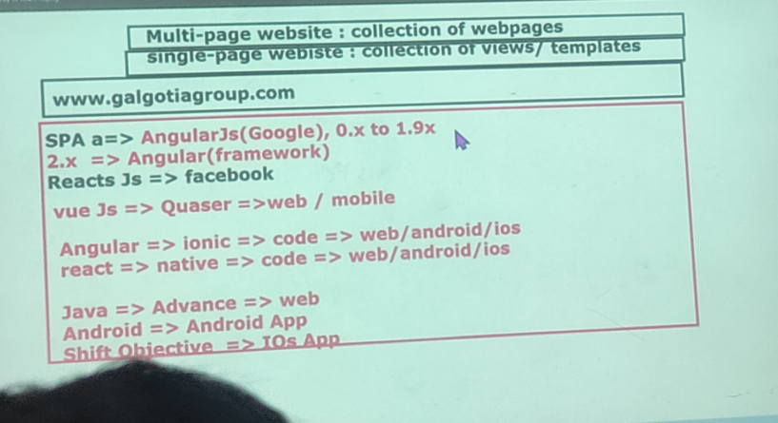

_**Working_**

[*SPA Vs MPA]*

spa = costly

__________

| pic:{} , |

| profile : {}, | => Component binding

| post : {}, |

___________

**props**

**Or**

**state**

**Or**

**data**

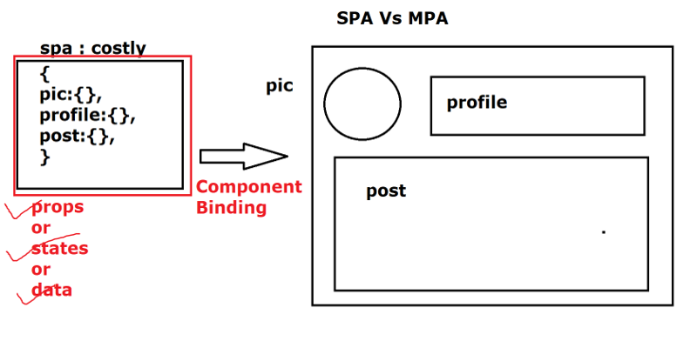

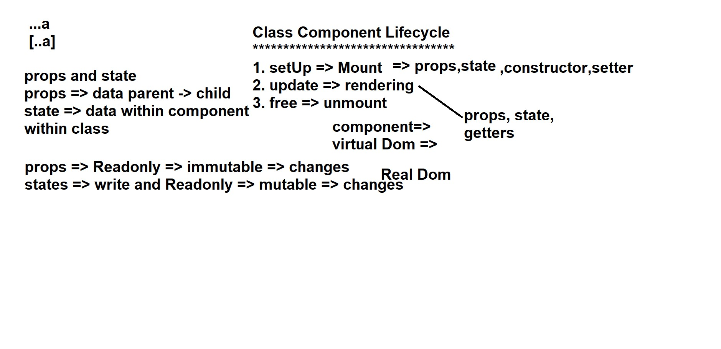

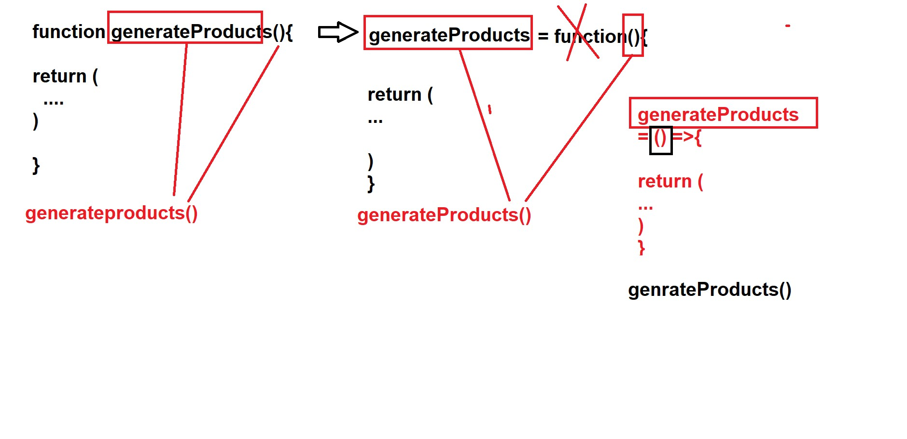

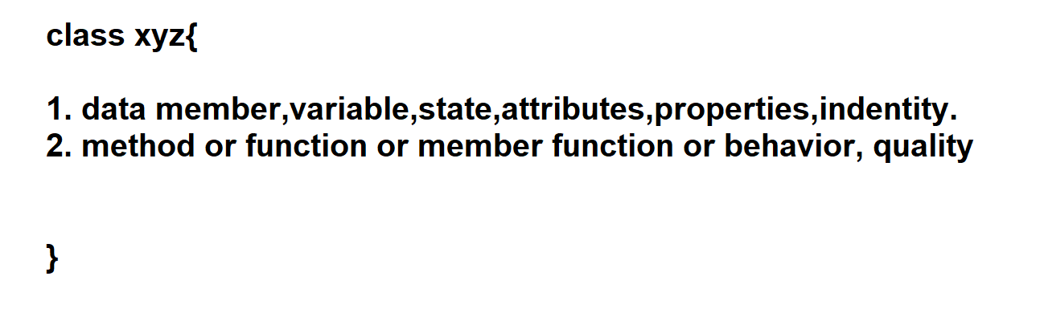

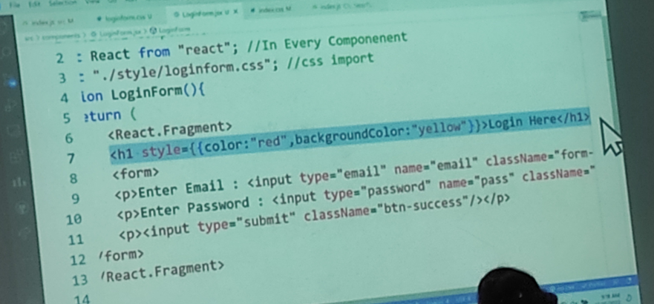

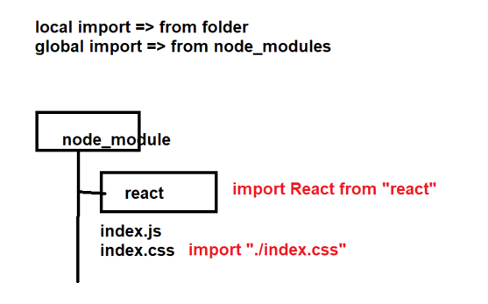

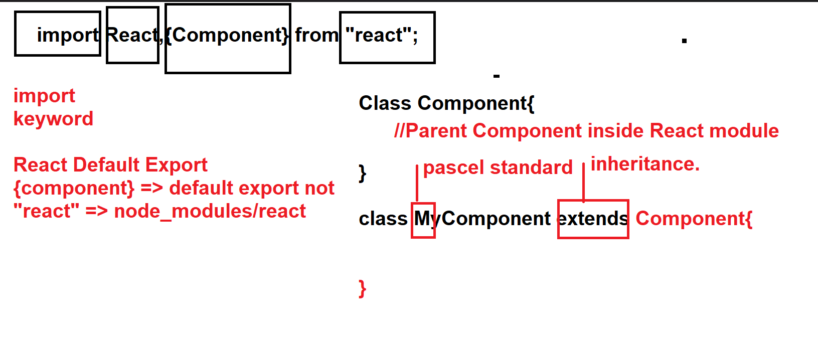

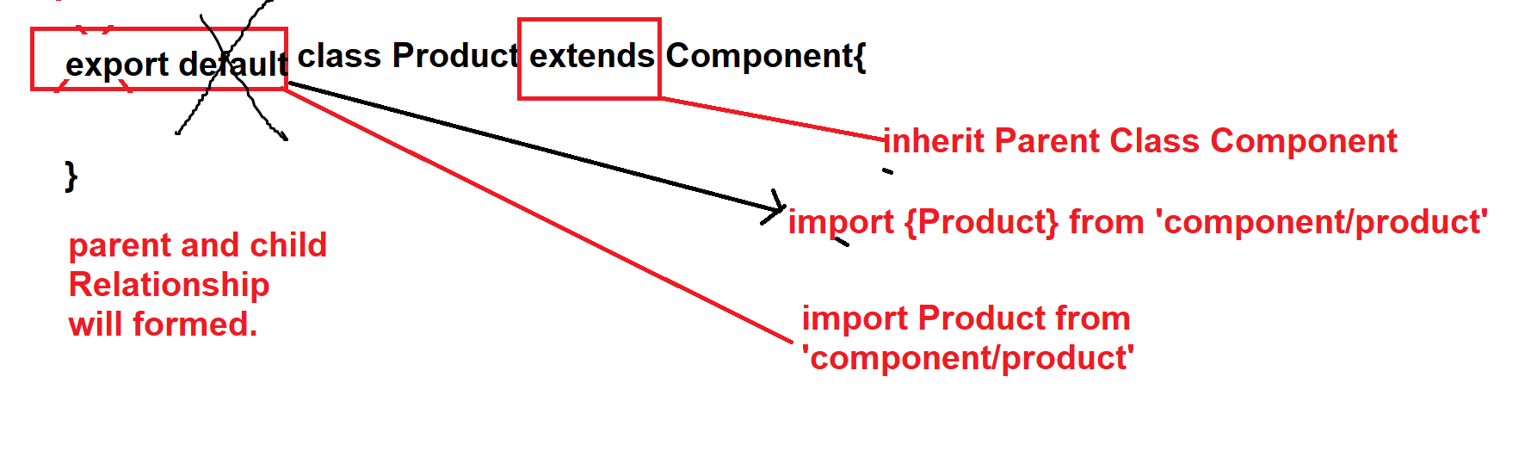

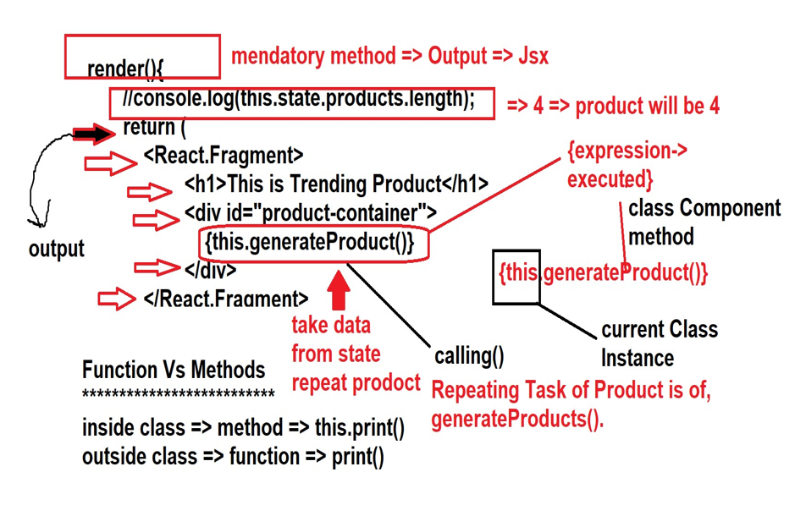

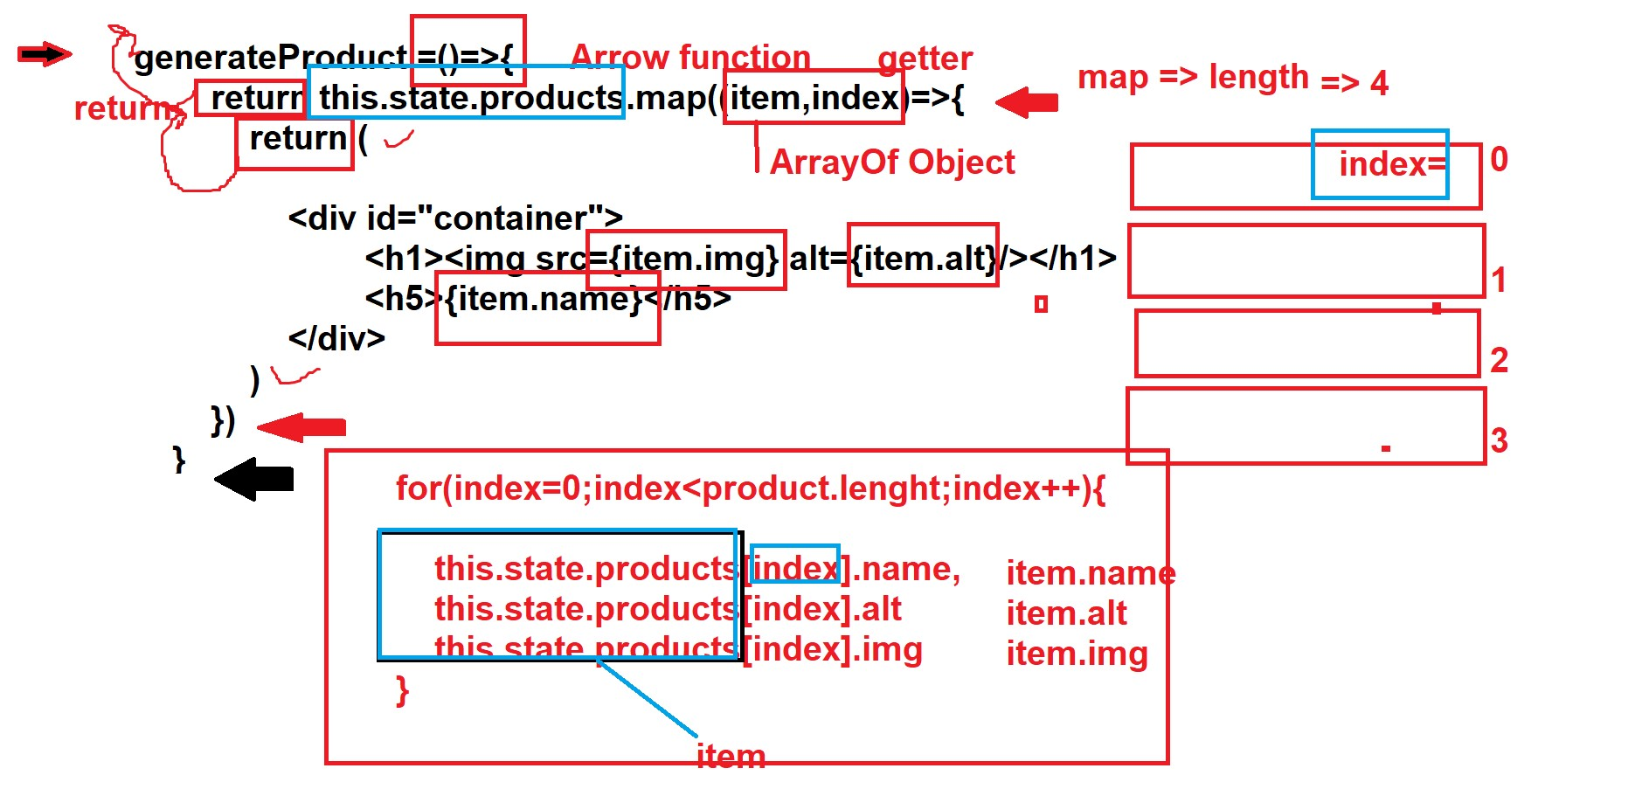

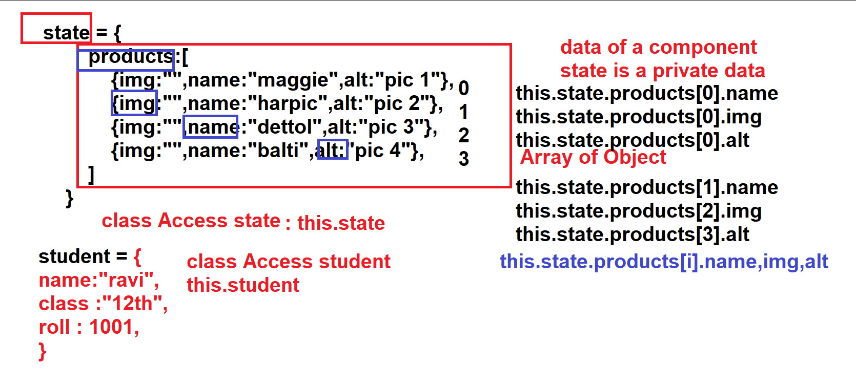

**4-12-2022**

**How to install ReactJS**

1.) ***Library***: AngularJs ==> Library lightweight source code, which is pre-build contains inbuilt functions.

Ready-made -------> code --------> Library

Library:-- helps on functionality.

Dance => dance decoration => different

halwai => food

Tent => tent

Marraige Hall => Stay and other...

2.) ***Framework***: Angular is a framework.

1. dance => dance

2. character => character

3. decoration => decoration

Event management

Library is a collection of functions and functinality.

While ,Framework is a , collections multiple library.

**Eg :-**

React - JS Install => service => create-react-app -------> bat

using this we install, a package using node

folder => +node modules

15k , libraries

**Ajax-laoding –**

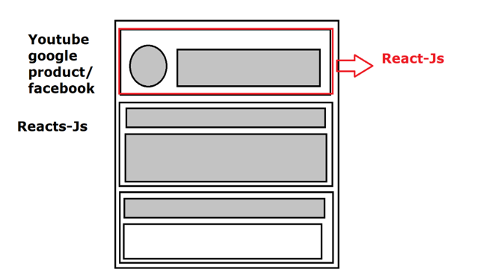

**Array [ { … } ]**

**React-Js-DATA –**

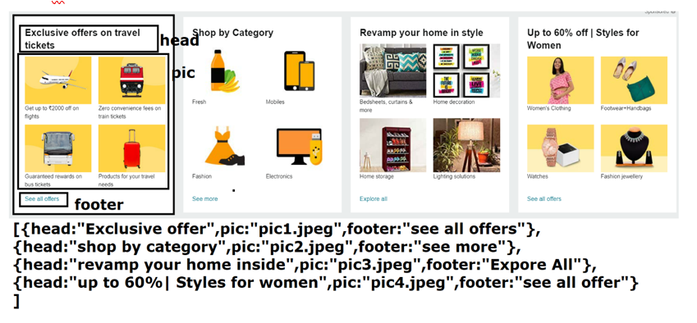

**varity of react-Js –**

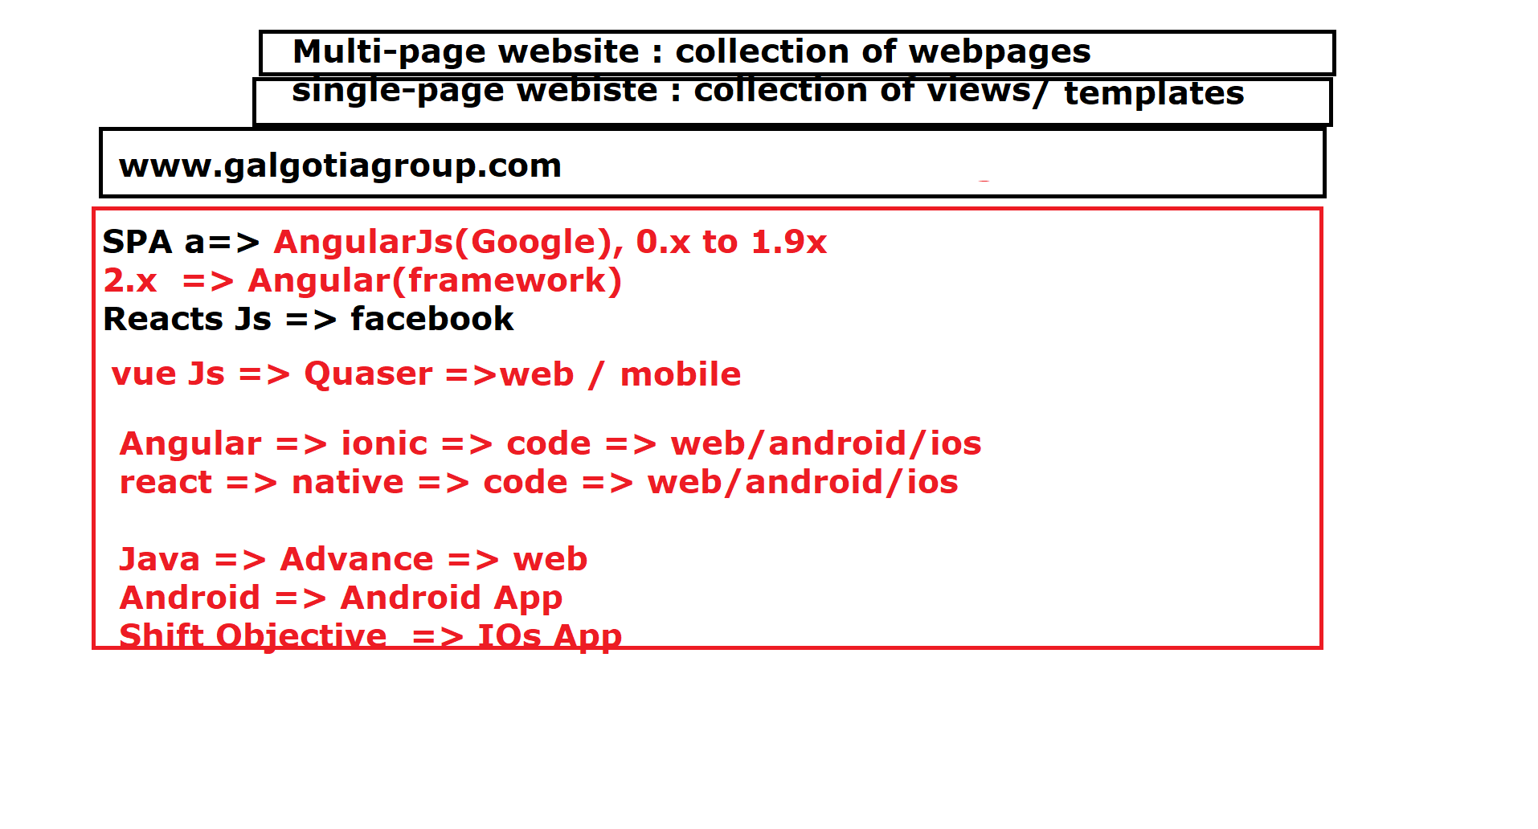

**npm package –**

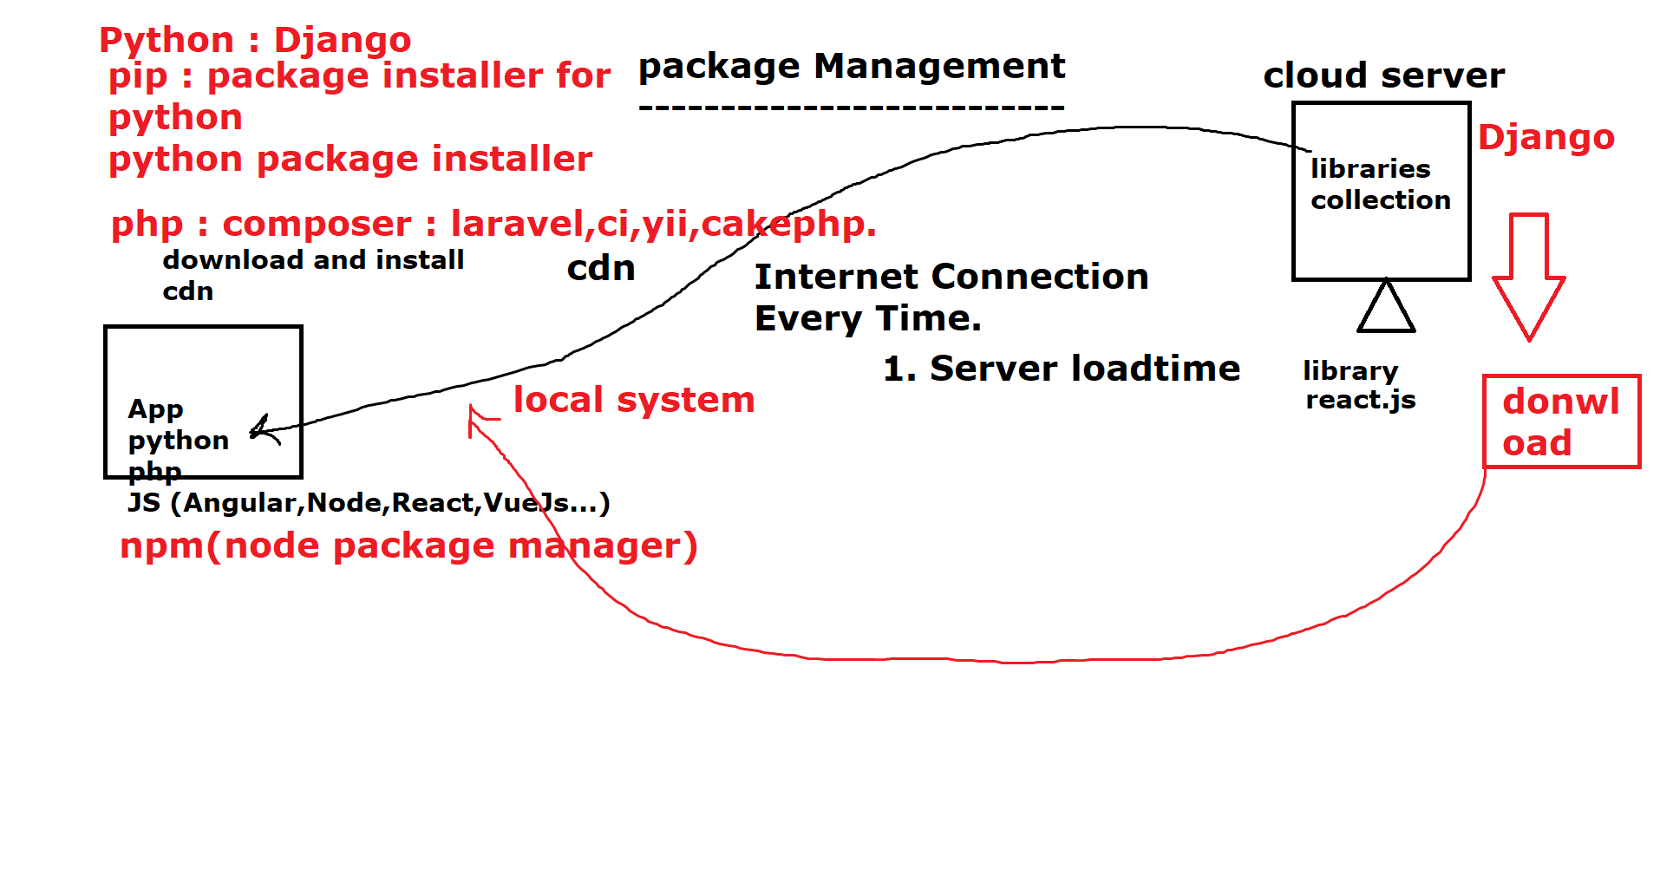

**How to install React-JS**

********************

1. **Two way**

*a) using cdn*: cloud/content delivery Network.

b) download/install and use

for this, we have to use npm.

**5/dec/2022**

**Question:** We are using React JS so why we are installing, node js we are using Node JS because it provides the server runtime Environment.

**What is the meaning of Server Side Runtime Environment?**

In order to explain, this we need to review the client and server Architecture.

When Ever we say a client is requesting a server it actually means that the request is send from the client to

DNS server (Domain Name Server ), after that each request is hopper from one server to another server.

this way one server which sends the request to another server becomes a client for the another server.

( based on IP ADDRESS connection mode ) .

Hence Any system can be made to behave as a server, but there are certain criteria.

hence our client cannot send the request to the server to directly download/install the package from the server.

hence instead of making the entire system server, we try to provide the environment to the system.

Hence the server-side environment which enables the JS as be used as a Backend service, that runtime

environment is nothing but **NodeJS.**

**Architecture of Node Js**

Google Chrome => Dev Tools => Environment Developer ,

| easy developer.

|

v1 Engine (Runtime Js and Runtime, DOM change)

Virtual changes ( All changes , which is generated at runtime but does not extist ) => virtual Dom => V8 dev tool

V8 Dev Tool ( exe) --------> Node js .exe js.exe

V8 Engine Archt.

2.) *Non - Blocking Mechanism* ( Asynchronous) -----> Parallel Execution

**How to check node is installed**

*open cmd* => type check ----> node -v

*open cmd* => version -----> npm -v

**How to Run using node**

node filename.js

**How to run using npm**

you can directly run the js file, for that you have to declare the file as the package ( module) Every file, is in a node in the module.

collection of one or Mode modules is called a package. and every package can executed using npm, and package.json.

**What is package.Json**

It is a special file that tells everything about a package.

it is a static file.

It includes information like title, description, author name, and dependencies (other packages).

**dependecies** => If a package is dependent on other packages then, as soon as you download/install one package all the packages related to others will be installed.

websites name, license, repo, name, git, url, jira, url .....

and it also includes, scripts (used to run commands)

**How to make package.json:-** make a file using the name

package.json and write code in pure JSON format .

{

" title" : " My first package " ,

" dependecies " : " This is demo package " ,

" license " : " MIT /ISC " ,

"author": "Soni NISHAD",

"dependencies": [ ],

"scripts": {

"dev" : "node p1.js"

}

}

**2nd method –**

npm init -y ==> dummy package.json

or

npm init

you will be asked file details and confirm .

automatically package

**6-12-2022**

**Types of Envoirenment Scopes in NodeJS**

***1. local scope***: to the current folder

***2. global scope***: to the global folder

~ /users/nodesjs/......node_modules/.....

|

( tild [ root path ] )

When ever a packages is Installed, it is either installed al local space or global space .

[

**command:-**

$ npm install

(package.json exist )

-------> why, because all packages sub packages details are stored

in, package.json

===> package.json

"dependecies": [

"uuid":"latest",

"mongoose":"5.0.1", 🡪npm .........

"express":"latest"

]

**What are dependencies:-**

**1.)** These are package or sub package which will install, as soon as we run the npm install command.

Dependencies are also called as packages which dependent , on other packages for running.

**Consider an example:-**

in the paint.

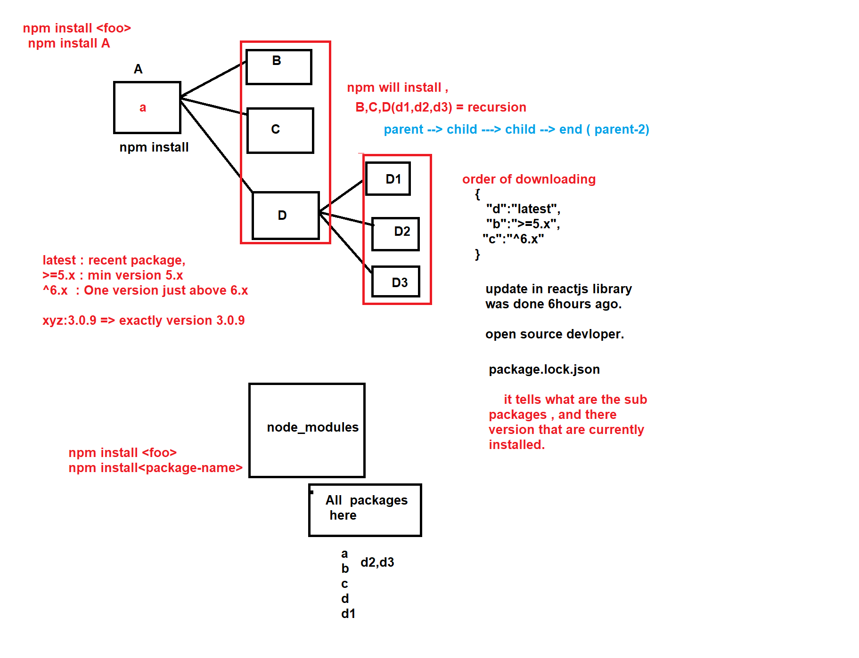

**what is npmrc ?**

npmrc is a, npm configuration file inside npmrc is only, written that the package file name should be "**package.json**".

----> npm config --json

**How many types of memory scopes** –

1. local

2. global

**Command to find where any service installed**

where < service-name>

EG :

where npm

Or

where node

**How to install any package**

npm install<packagename>

**7/12/2022**

**Starting first App in React :-**

In order to make first project of react .

we need a service called create-react-app .

cmd or create-react-app bat file for creating first app.

gallery page => gallery.html

faq page => page.html

contact page => contact.html

**………………………**

**……………………..**

Every project is a App . , and every time to build new app you need to download react App from scratch( ) .

1. dev => developer point of view .( dev Environment)

2. out of the box => by default .

3. scratch => from starting

4. boyler plate => starting template ( some prexisting theme OR code )

5. hunch => curiosity

6. KT => knowledge Transfer .

7. On Bench => No project Alignment .

8. test => tester point of view .

**How to install React :-**

npm install --global create-react-app <= first time process .

**How to create React App**

npx create-react-app <app-name or project-name>

**What is the difference Between npm and npx?**

**npm =>** node package manager. -----> install package from cloud server

https://nodejs.org

Or

https://www.npmjs.com/ => cloud repository, all package of node are installed

npx => node package executable.

npm ----------> JS ------------> execute.

|

|

package.json

(declare this Js is module)

npx => execute this package

**Note ::** Every time you download app you will need , internet connection ( + data pack )

**For locally Install node steps ….**

1. Open VS code
2. Nd make new folder and usi folder me CMD open kare
3. npm init



1. file name



1. version



1. license …….etc…..
2. then “yes”

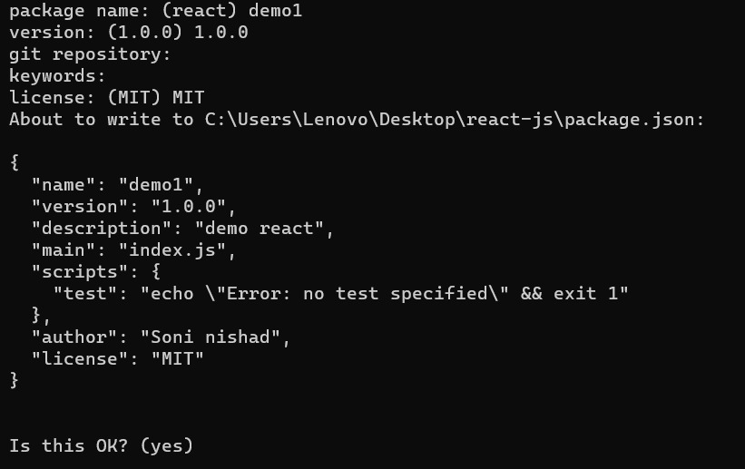

Finally:-

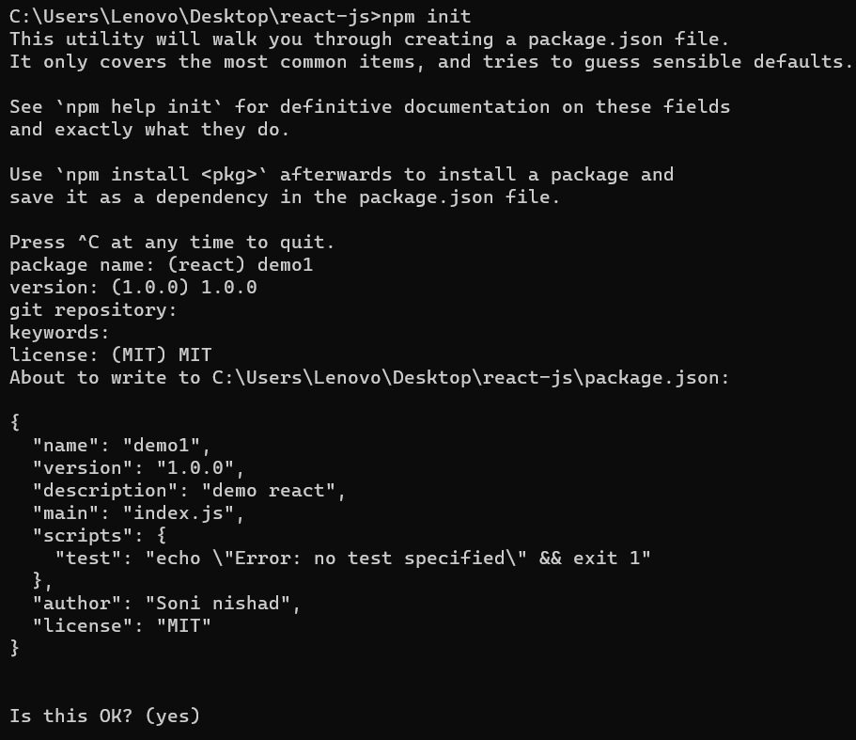

php -----> constant salary rhtii.

fast.com ---> for checking data speed

https://www.npmjs.com/package/create-react-app

IN Folder: -- in result, ek new file package.json ban jati hai .

Most important :

  "dependencies": {

    "create-react-app":"latest"

  }

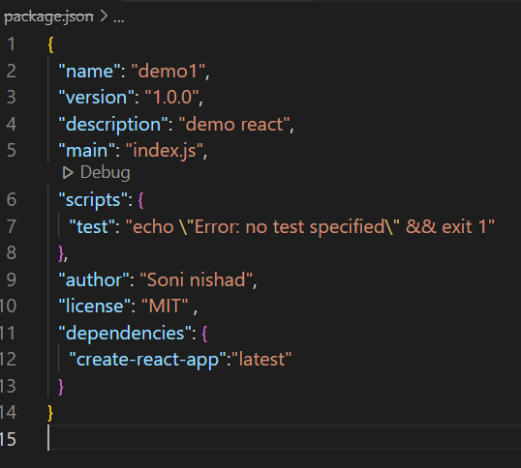

**React download globally :**

***npm install***



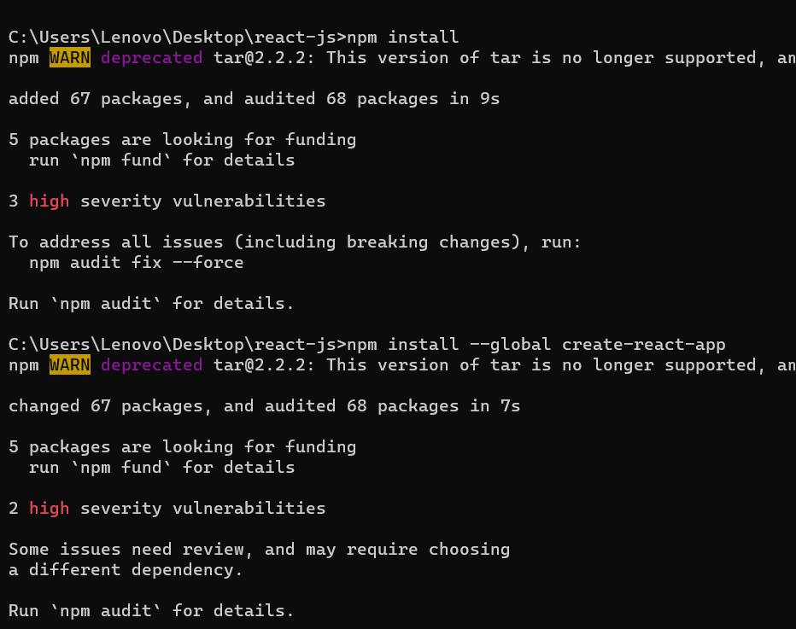

2. where node

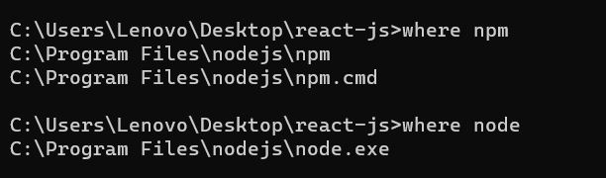

3. create react app : **npx create-react-app Appname**



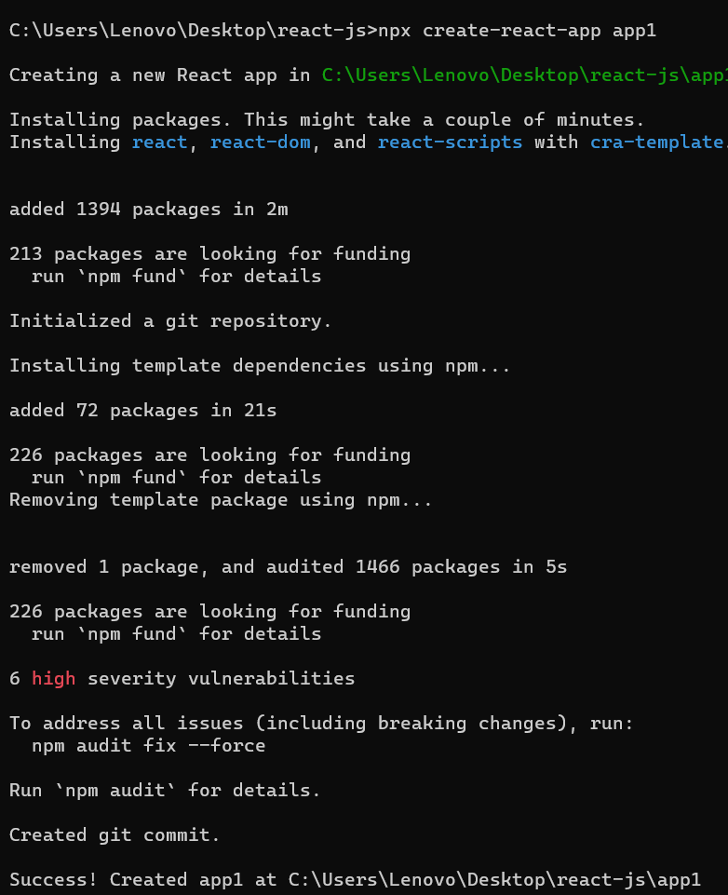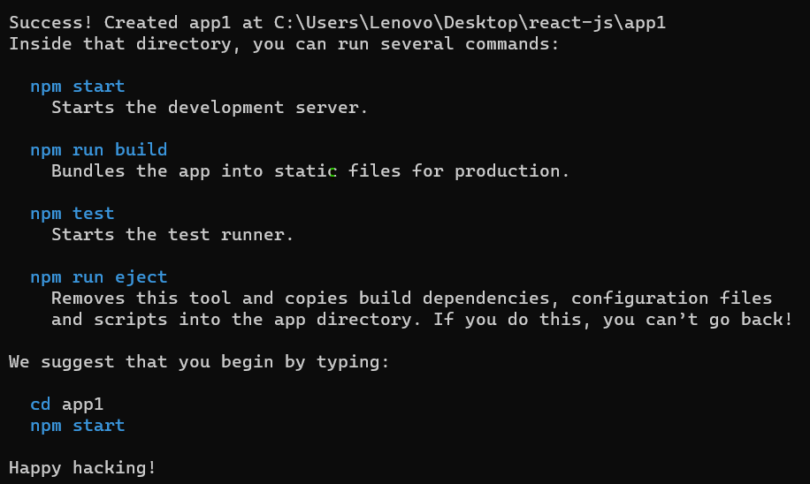

Finally download globally.

13-dec-2022

**App 2 download:-**

1. npm install 🡪 ye
2. npx create-react-app app2

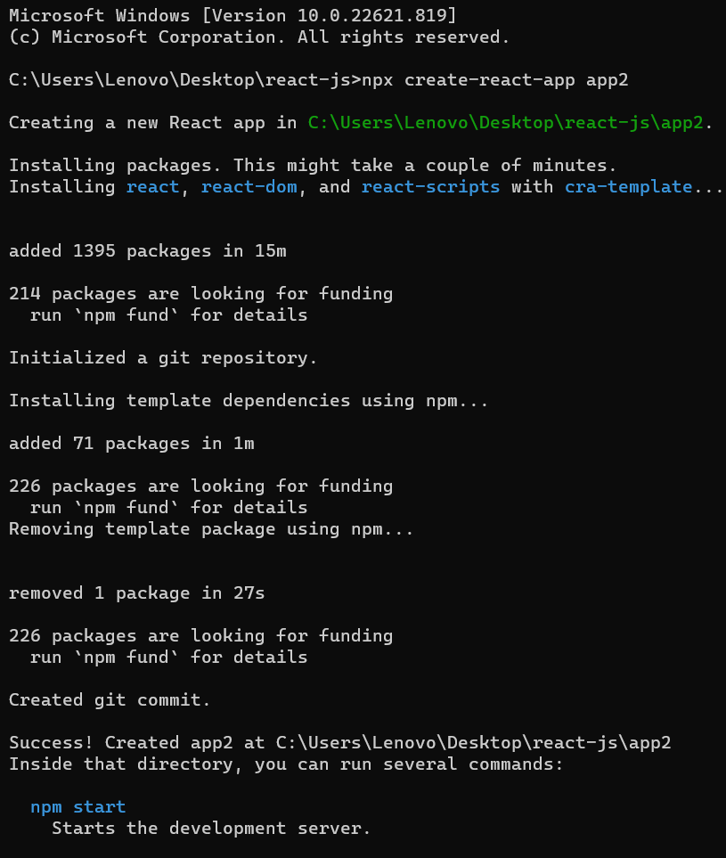

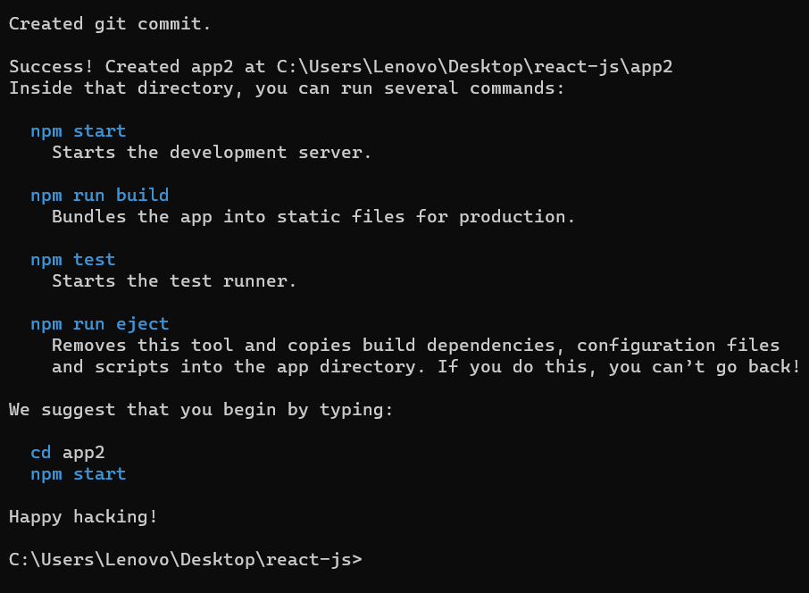

**________________________________________________________________**

**For createing first folder :**

**Folder :-**

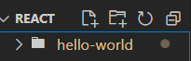

**For Running :**

**=>** npm start

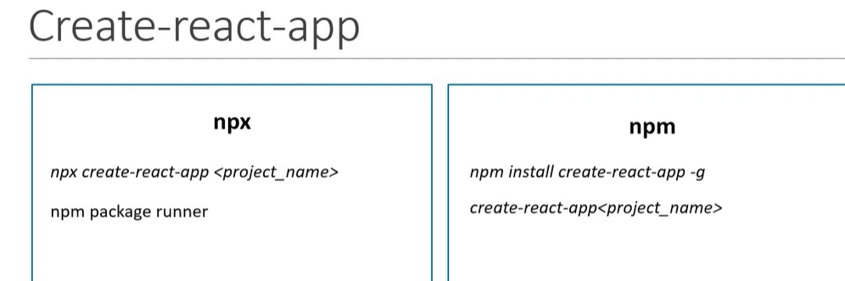

**Package Creation :-**

**How to setup New npm package :-**

npm init

**Make folder :** nd usi folder me jakar CMD ya Powershell open kare.

Shift + Right Click --🡪 Open with window Powershell / CMD .

npm init

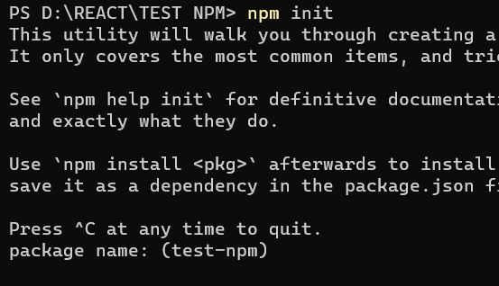

**Package name :** Agar nhi bataoge to vo *folder ka* *naam*hi [ package-name ] me likh dega .

**Version :**

**Description :** mtlb package kis liye hai / default bhi use kar skte hai.

**entry point :** main file kon si hai vo likhte hai.

**Test command :** // default

**Git repo :** isme git repo bhi likh skte hai / space (default) bhi chor skte hai.

**Keywords :** array of string likh skte hai ( “ .. ” ).

…………….. so on .

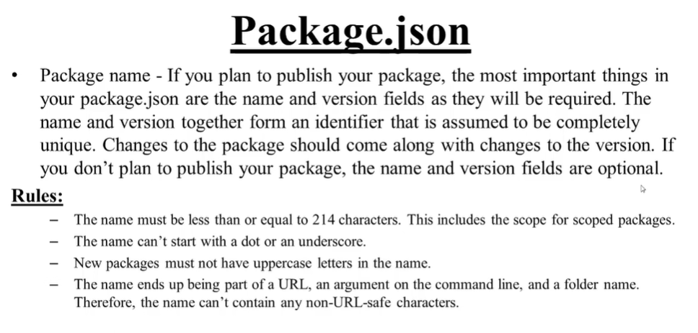

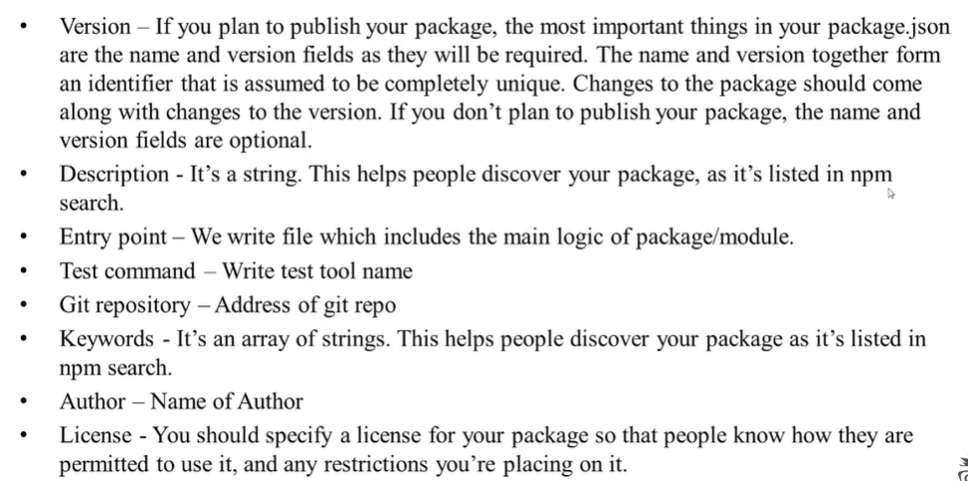

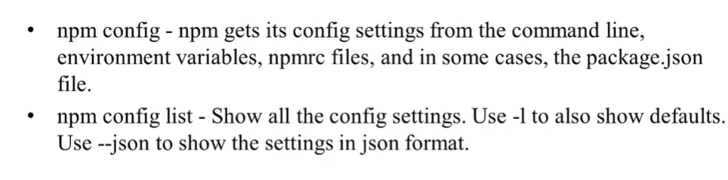

**Config :-**

npm config list

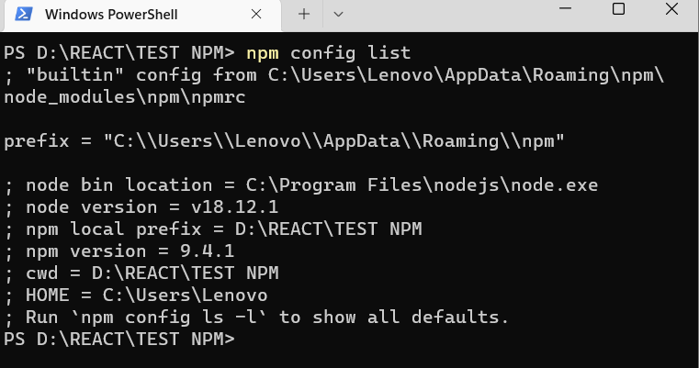

Here list is a sub command .

For all seeing [ complete list] -🡪 npm config list -l

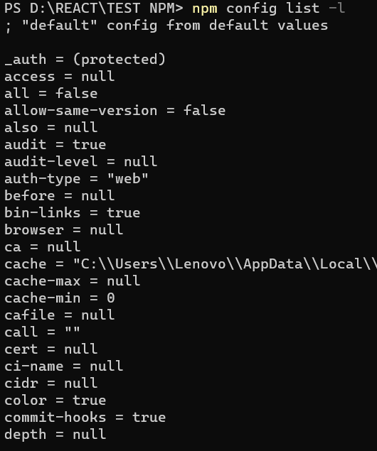

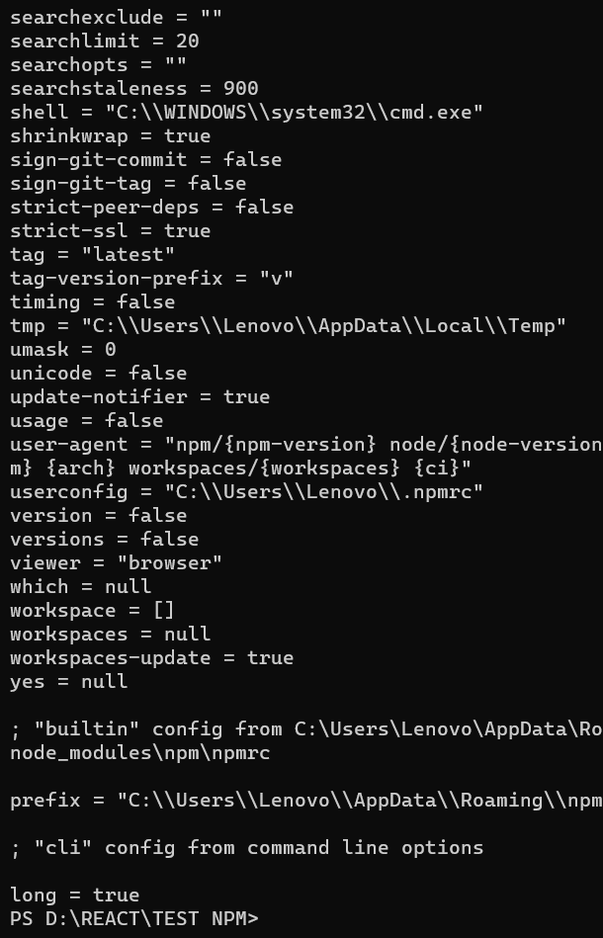

Key = value 🡪 pair

npm config set init-author-name 🡪 author name me value set karne ke liye.

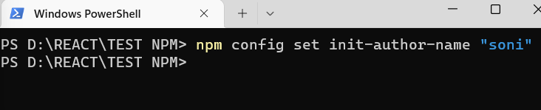

npm init -y 🡪 Agar aap sari value default dena chahte hai and app create karna ho to ye command use kar skte hai .

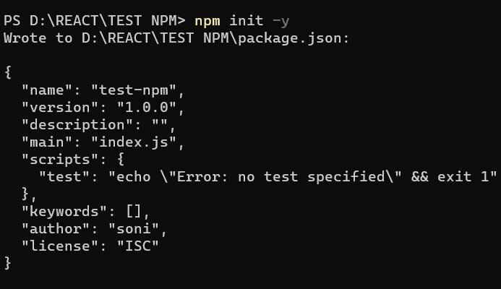

npm config get init-author-name 🡪 check karne ke liye ki author name me kya value di gayi hai.

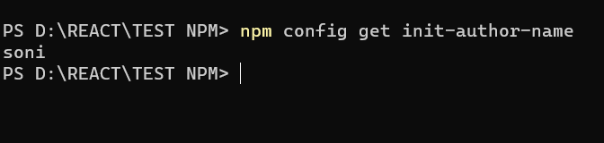

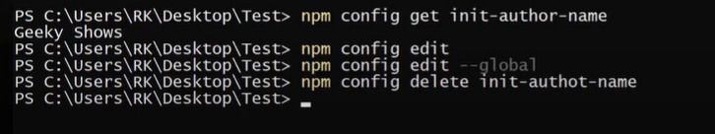

**Package/Module Installization**

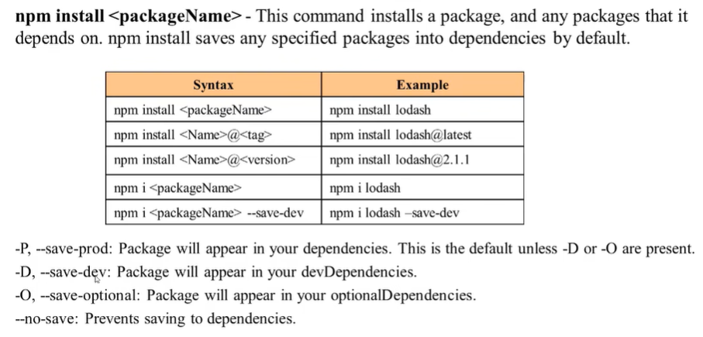

npm install lodash 🡪 package

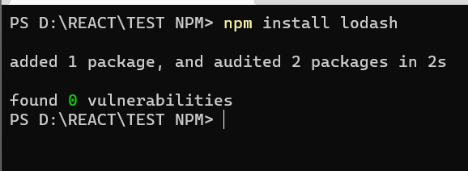

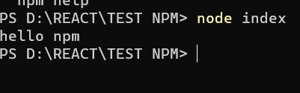

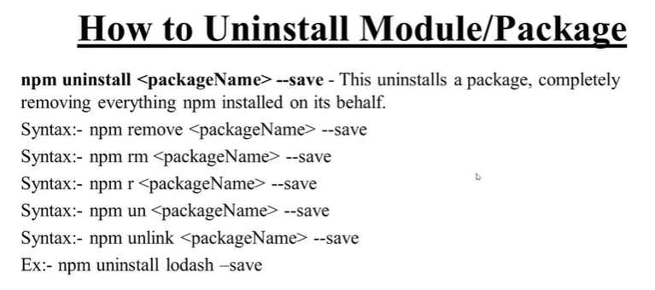

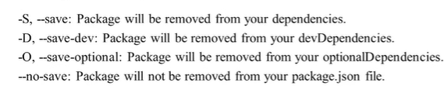

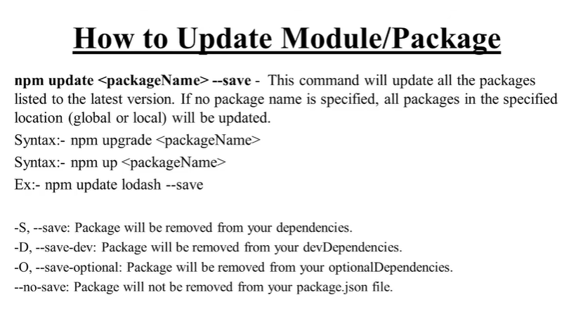

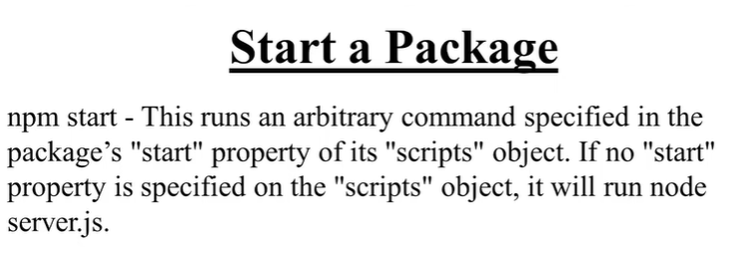

**How to setup React App using NPM –**

**Create React App :--**

**npx create-react-app FileName**

**Ex : npx create-react-app my-app**

**For running :-**

**Cd .\fileName**

**npm start**

**Ex :- Cd .\my-app [ powershell /cmd run react code]**

**Project Name : project name hamesa Small letter me create karte hai .**

**Capital letter me error show karta hai.**

**Directory Structure .**

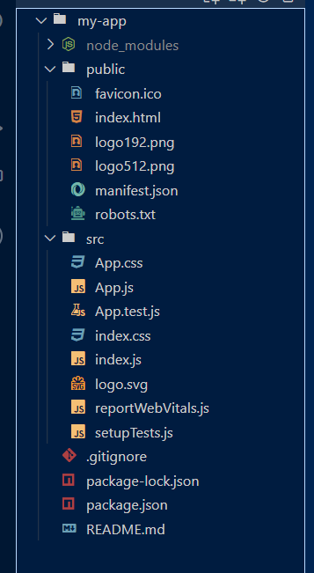

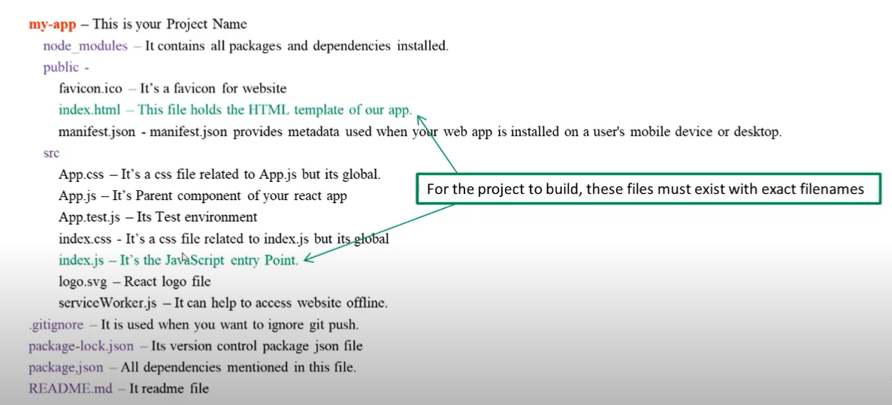

**Public Folder .**

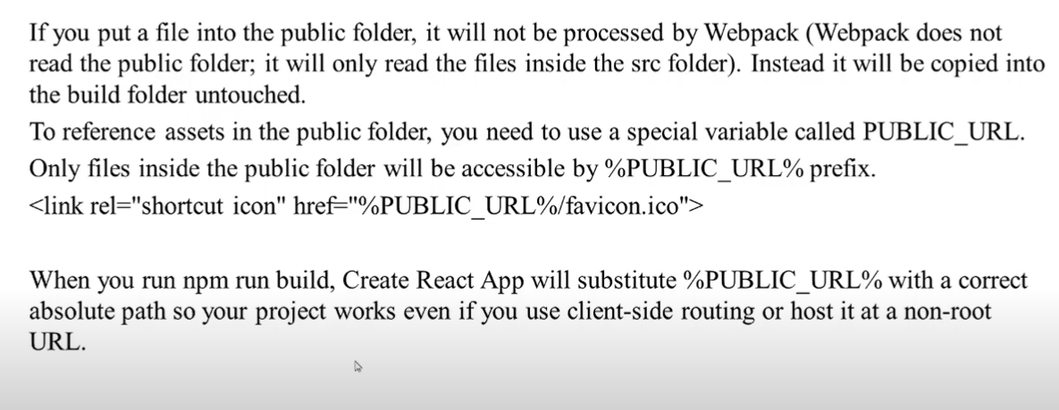

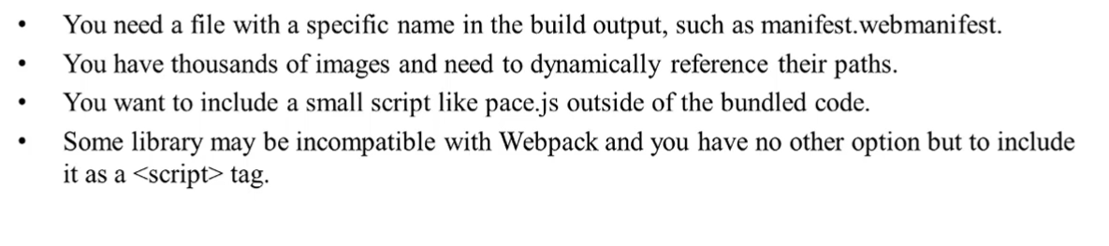

**First – react-App :**

For Making directory –

mkdir React-Practice

**For creating app :**

* **npx create-react-app my-app**

**For running app :**

* **cd .\my-app**

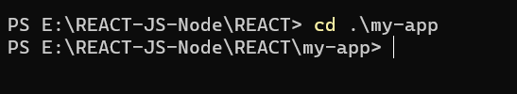

* **npm start**

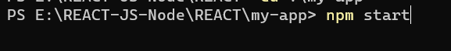

**Create app –**

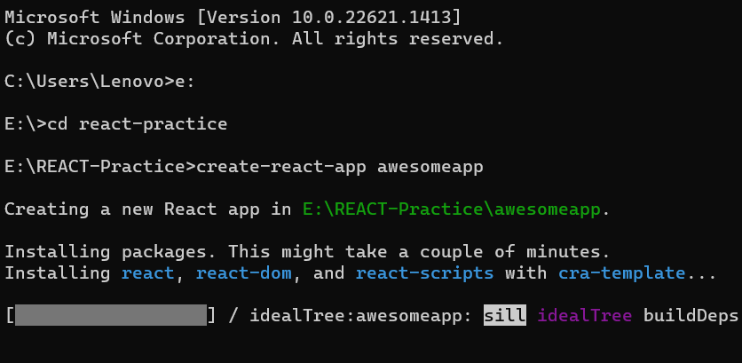

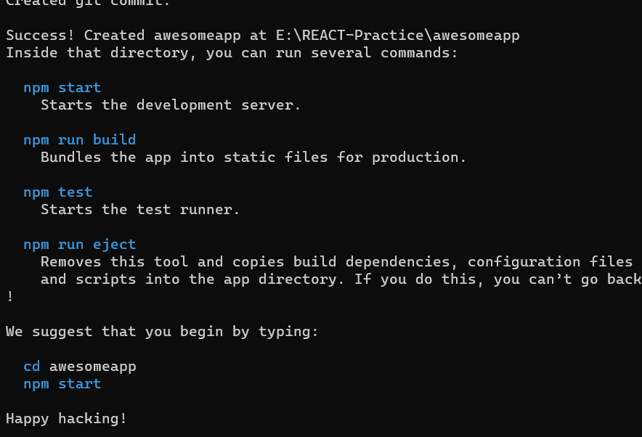

**Completely created …**

**For Running –**

**npm start**

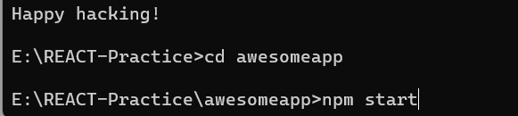

**After running –**

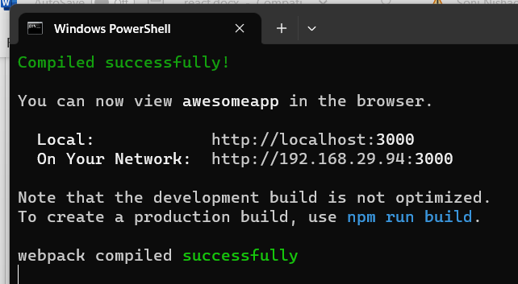

**Index.js is most important file.**

**We can changes here…**

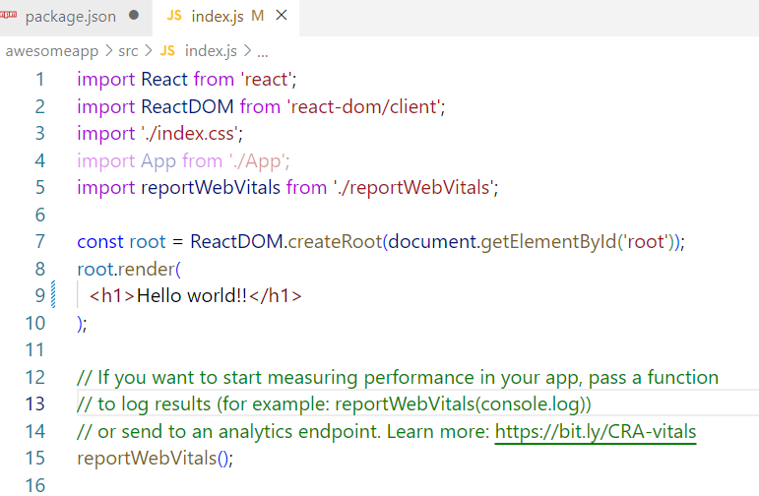

**🡺**

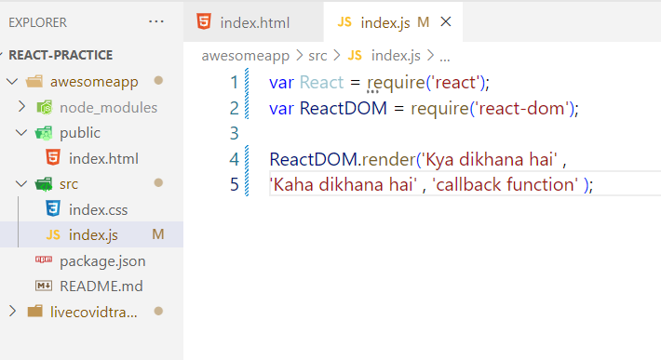

**React JS**

* **React is javascript Library. It is not a framework.**
* **Angular JS is a freamework of Javascript.**
* **React is a Single page web Application.**
* **Fast making UI.**
* **React is fast more than angular,Vue.**

**WHY LEARN –**

* **Long term player.**
* **Hight demand due to fast speed.**
* **Large Community for your support.**
* **Mobile app developer with React-native.**

**History & Version**

* **Maintained by Facebook.**
* **First release on 29 May 2013.**
* **The Current version is**
* **Apps with React is:**

1. **Netflix,**
2. **Whatsapp web,**
3. **Instagram (React-Native)**
4. **Airbnb etc.**

**First appli….**

**npm install --global create-react-app** <= first time process.

**How to create React App**

**npx create-react-app** <app-name or project-name>

First project

Check –

🡪node

**Making Form Using React –**

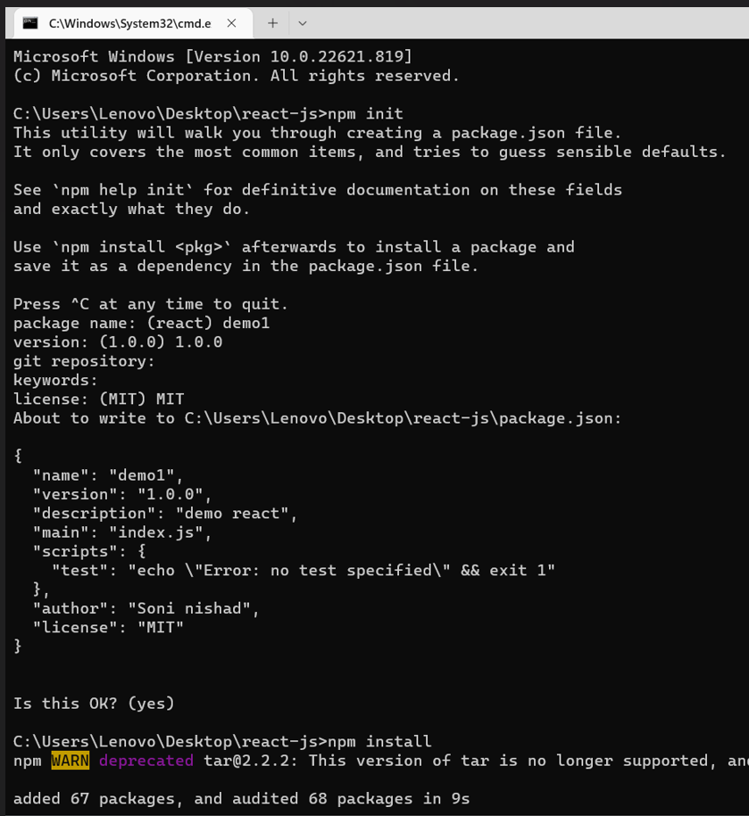

🡪

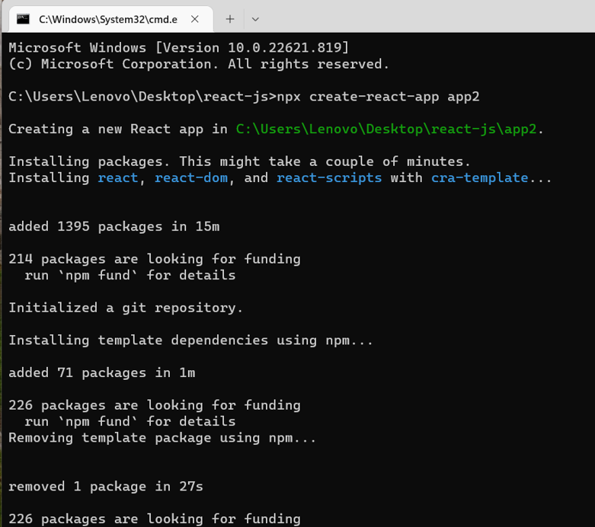

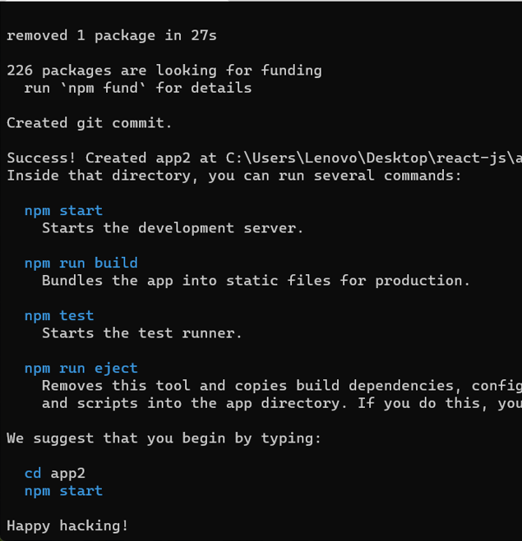

* Using cmd App is ready

🡪 Run

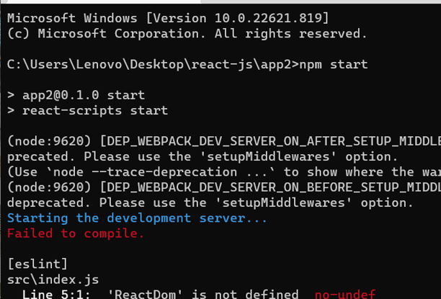

🡪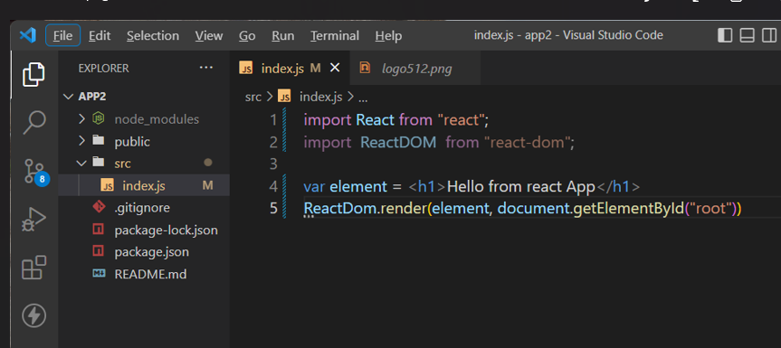

🡪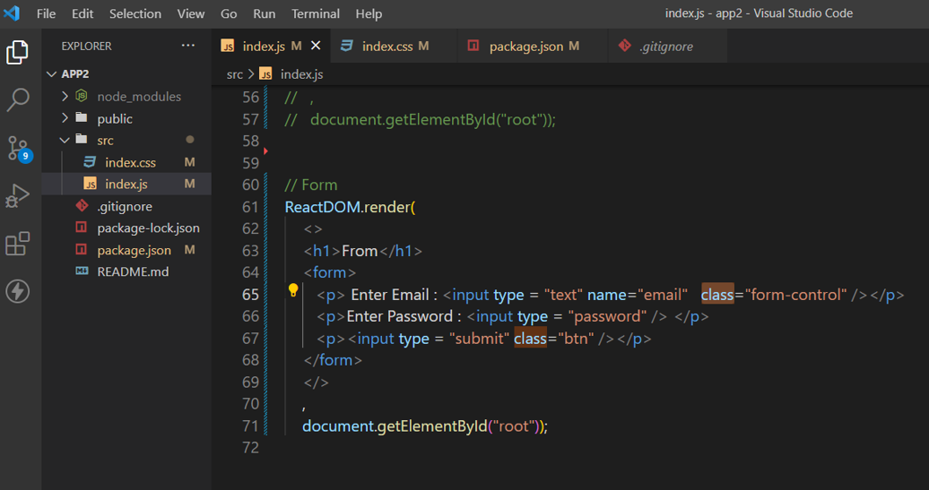

🡪Output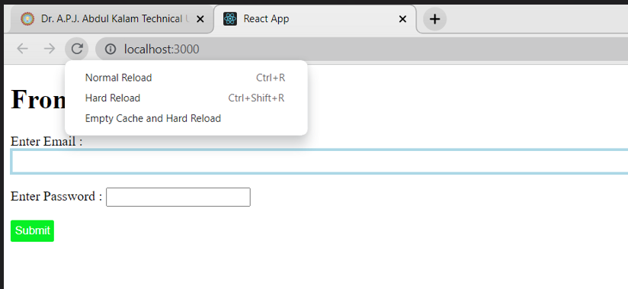

🡪

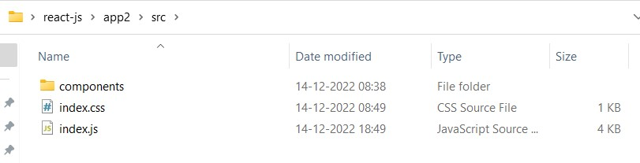

🡪

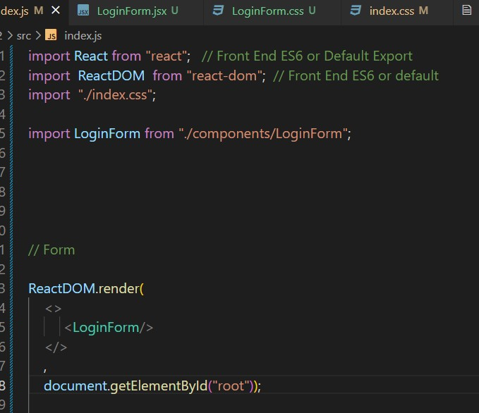

🡪

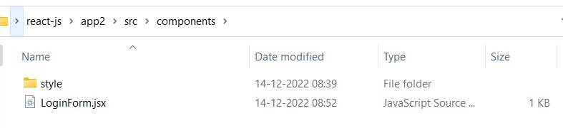

🡪

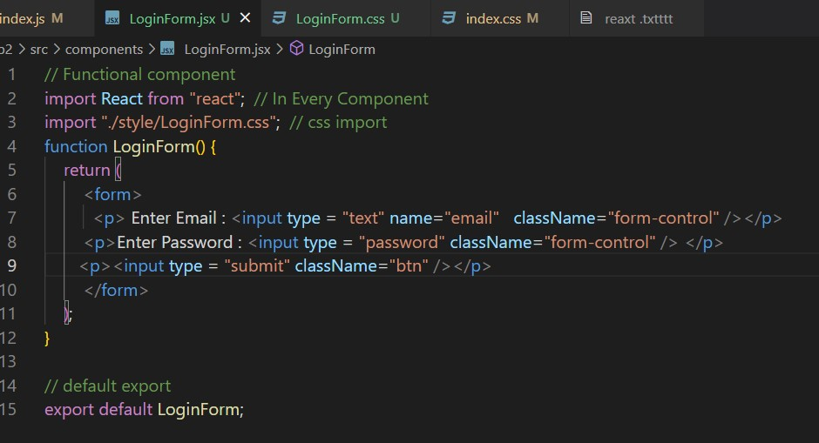

🡪

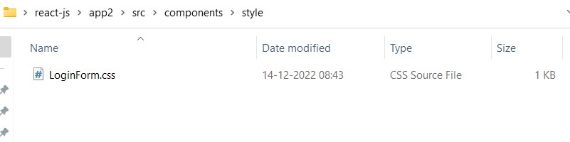

🡪

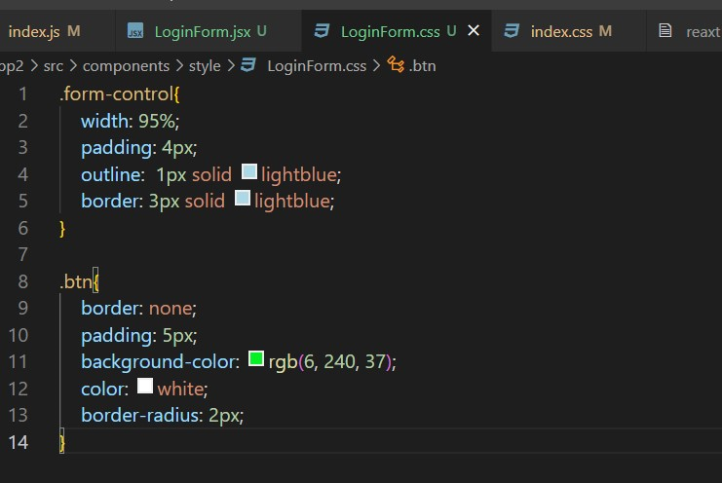

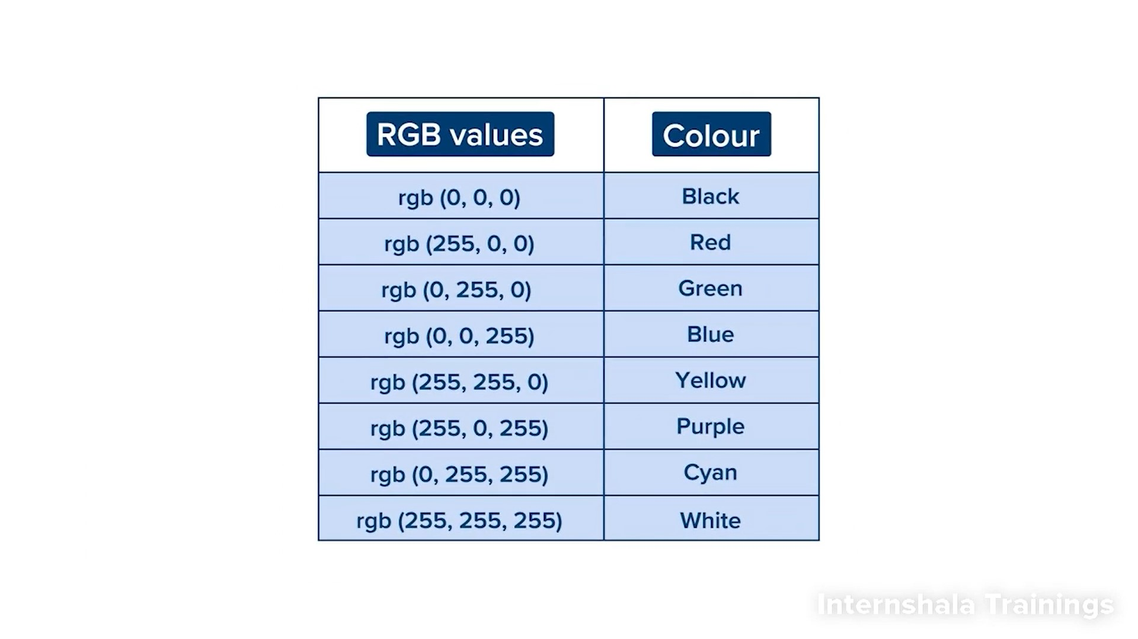

🡪

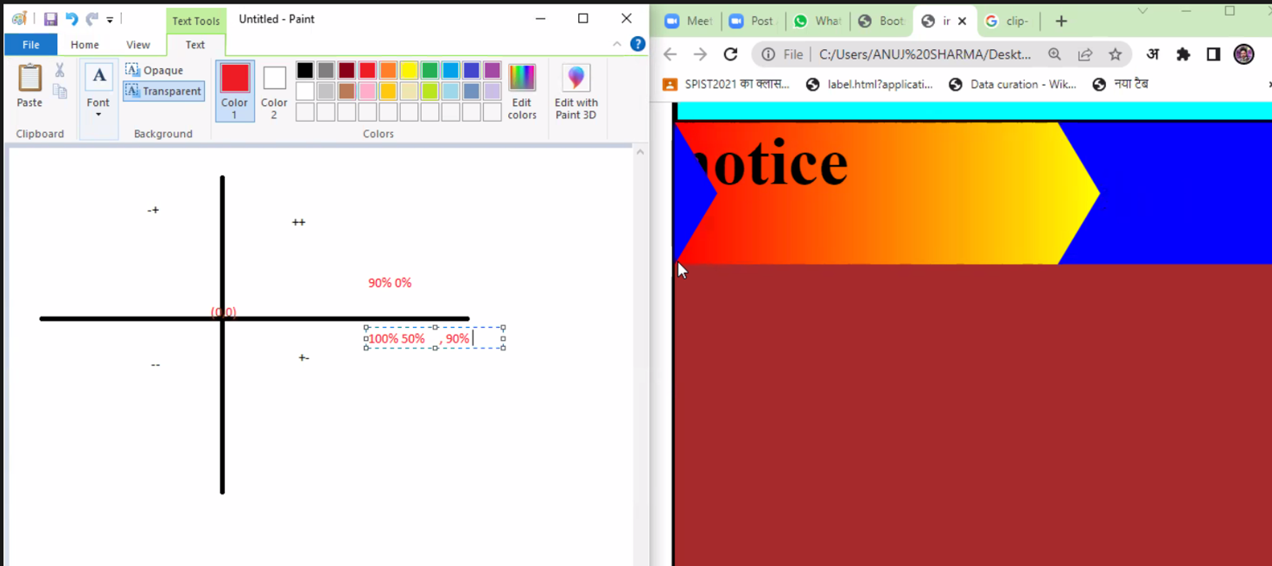

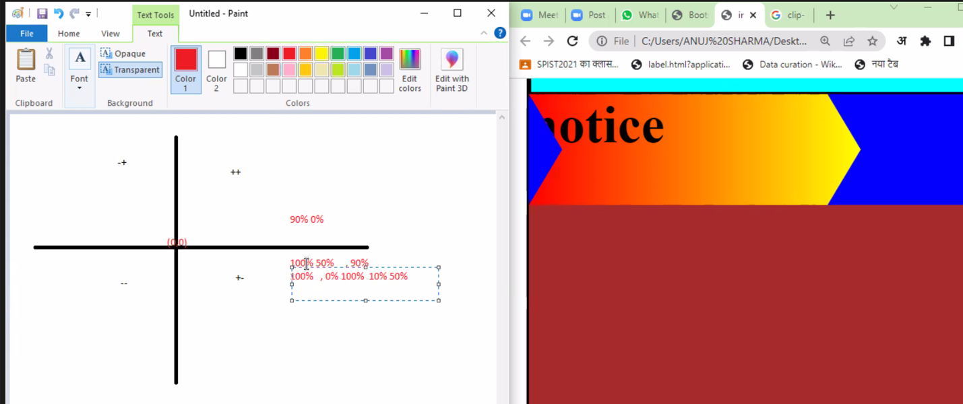

🡪

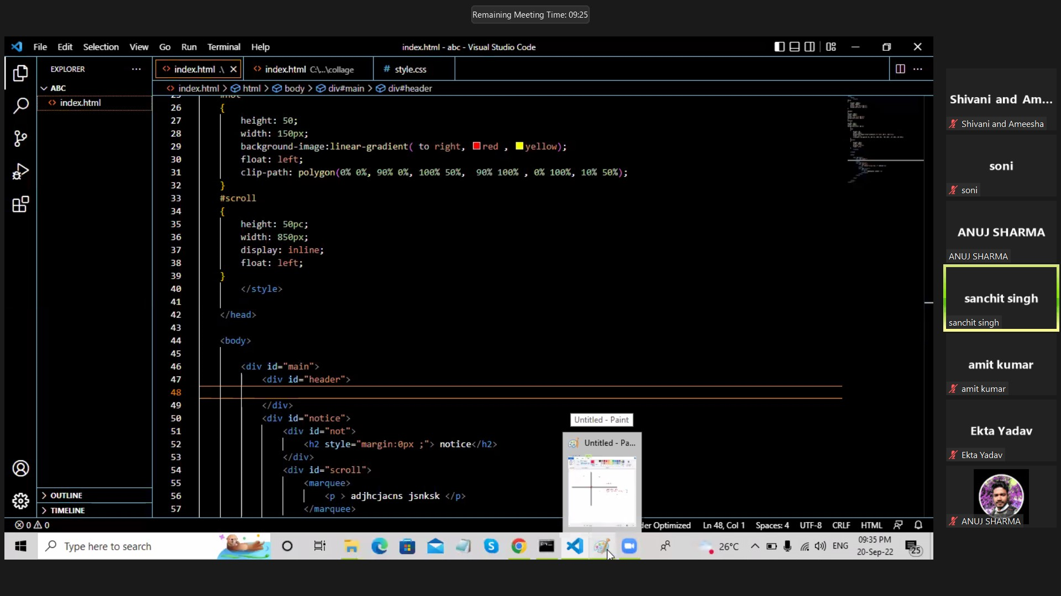

**Project using React**

Step 1:

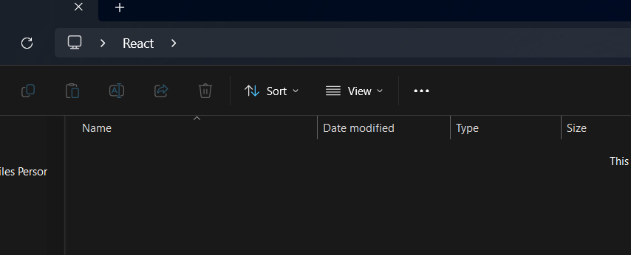

Step 2:

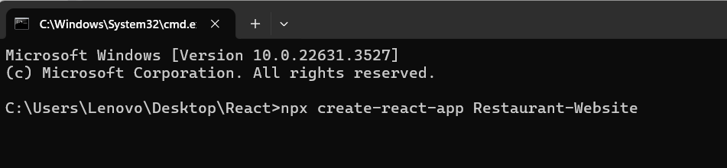

Step 1:

Step 1:

Step 1:

Step 1:

Step 1:

Step 1:

Step 1:

Step 1:

Step 1:

**Globally Install –**

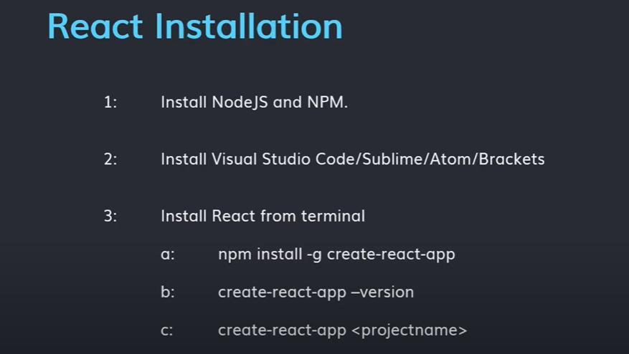

1🡪

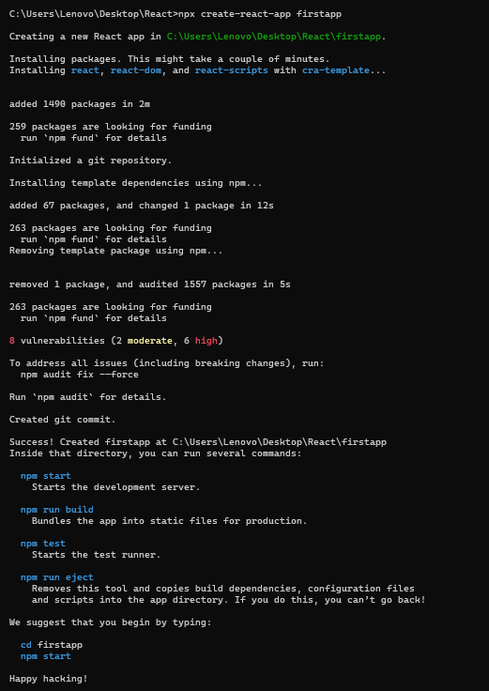

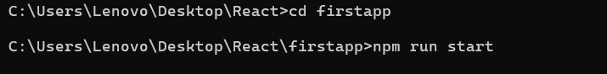

🡪Which folder

* Public
* Src
* React 4 types ki files me kaam kar sakta hai

1) .JS FILES

2) .JSX Files

3) .TS Files

4) .TSX Files

JSX FILES -🡪 JAVASCRIPT + XML

Working 🡪 Javascript code and html code ko sath me use kar skte hai.

**MY APP project –**

**We have covered Basic Topics like**

1. Props and Prop Drilling

2. Hooks - useState, useEffect, useRef

3. Forms in React

4. Mapping Components

5. Conditional Rendering

6. Node Package Manager (NPM)

Advanced Topics like:

1. React Router DOM

2. Code Optimisation Tips

3. Redux

4. Redux Toolkit

5. Redux Persist

6. Context API

7. Best Folder Structure for React

npm create vite@latest

javascript

react

_____________________________________________________________________

import React from "react"; // Hooks, Statesless App

function About()

{

}

export default About;

__________________________________________________________________________

Shortcut ---> rfce

___________________________________________________________________________

App.js (for see the browser)

App.js -->src

screens/About.js

Ex-- import About from './screens/About';

./ --> current directory

../ --> to move to a directory above

1. props --> object

2. Hooks

1. Props and Prop Drilling

2. Hooks - useState, useEffect, useRef, useMemo

useState() --> (form input define) ( input value ko store kar skte hai)

useEffect() --> first run refresh

useMemo() --> maximum calculation.. (cache - baar bar render nhi krna pdta value ko )

**React Router DOM**

**🡪** [**https://reactrouter.com/en/main/start/tutorial**](https://reactrouter.com/en/main/start/tutorial)

npm create vite@latest name-of-your-project – --template react

# follow prompts

cd <your new project directory>

npm install react-router-dom localforage match-sorter sort-by

npm run dev

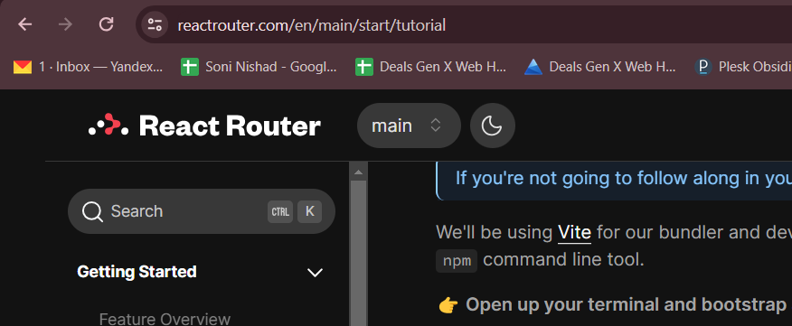

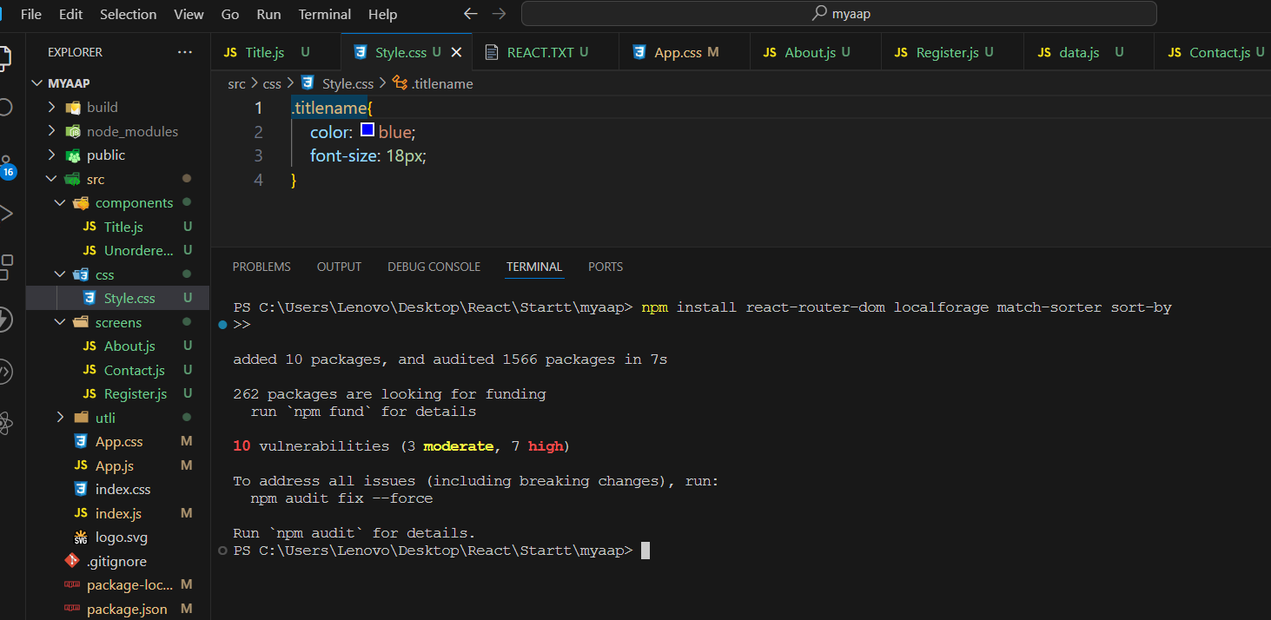

**React Redux**

* **https://redux.js.org/introduction/installation**

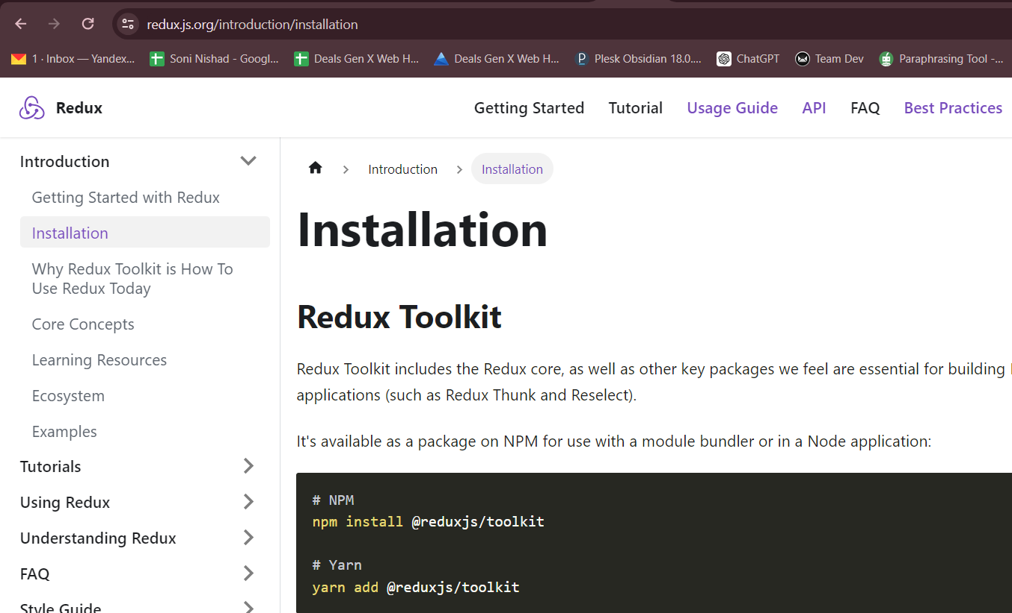

**# NPM**

* **npm install @reduxjs/toolkit**
* **npm install react-redux**
* **npm install redux**

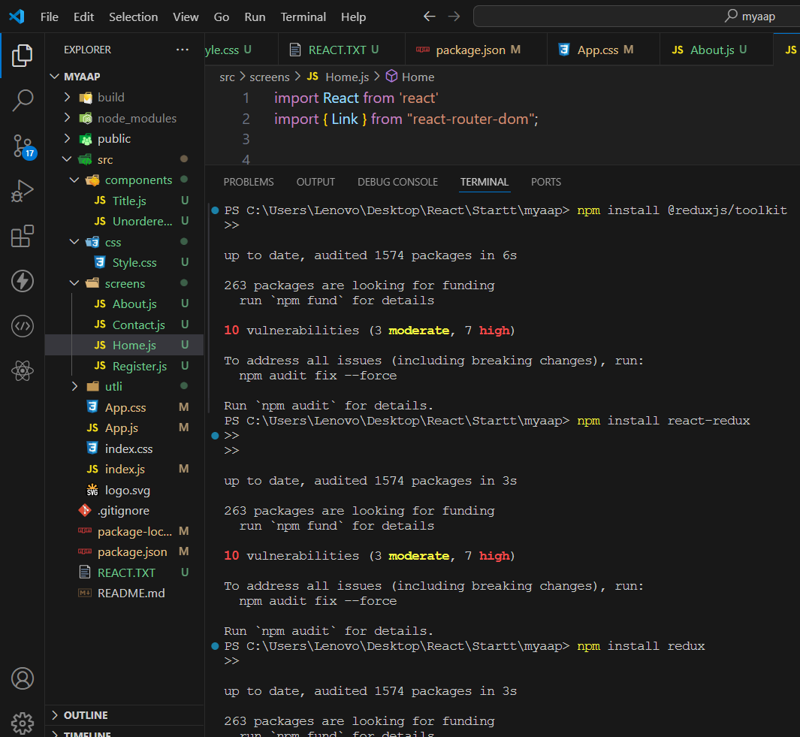

🡪 **npm create vite@latest**

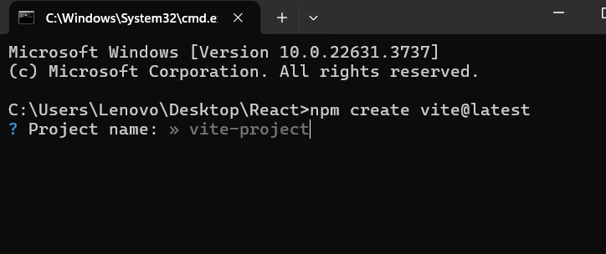

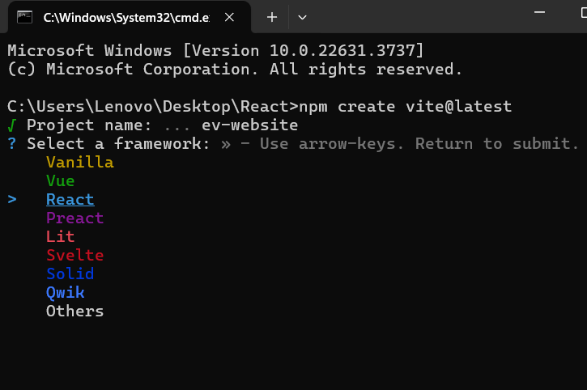

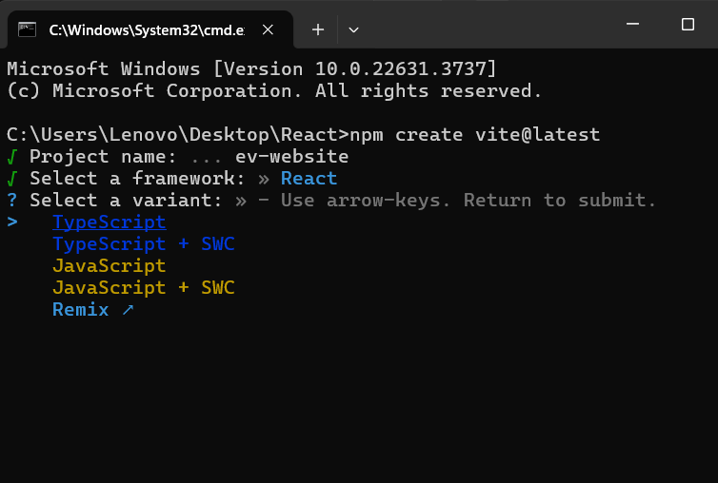

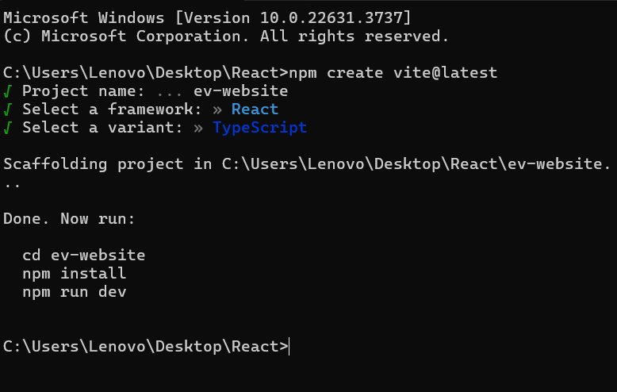

* npm install
* npm run dev [for running site]

**How to add TailwindCSS –**

[**https://tailwindcss.com/docs/installation**](https://tailwindcss.com/docs/installation)

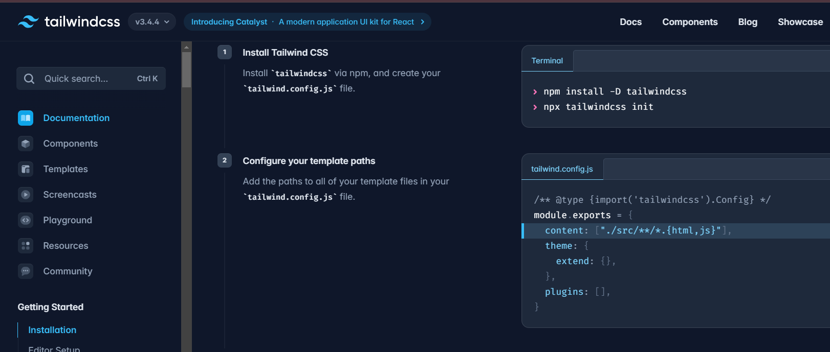

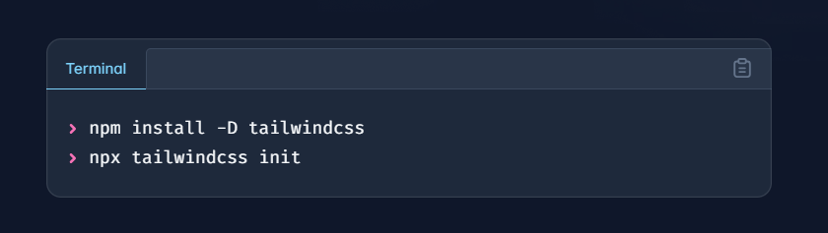

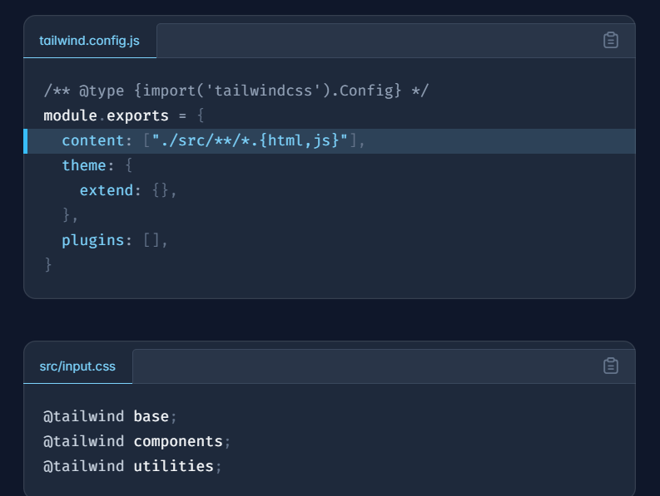

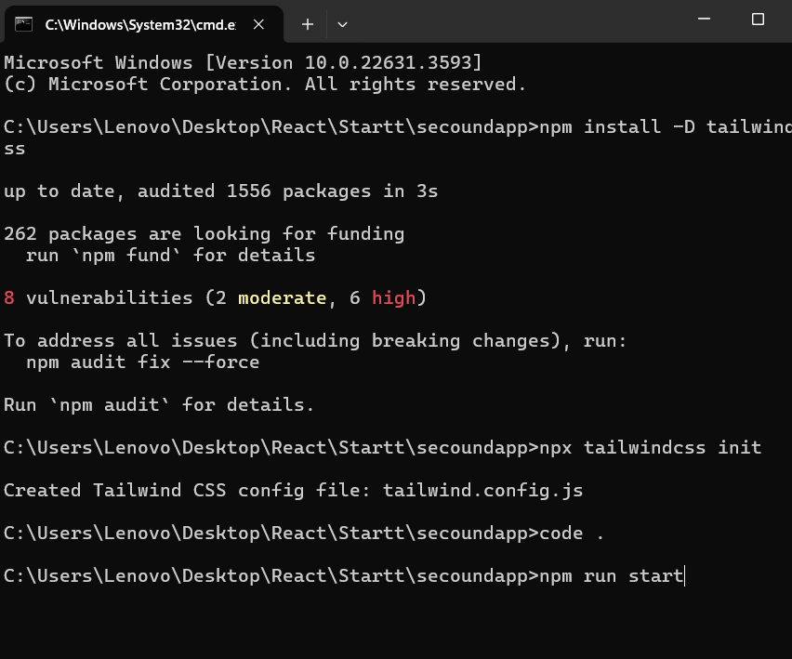

How to add CSS –





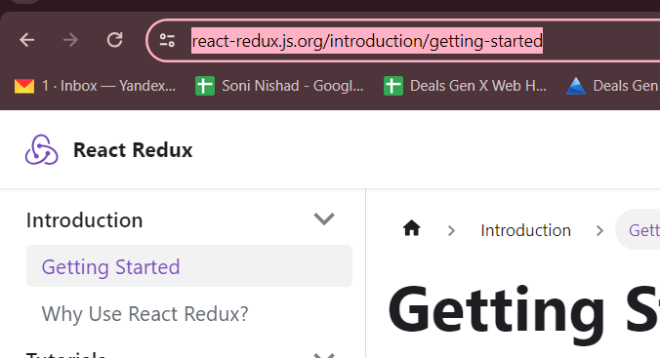





How to add BOOTSTRAP –

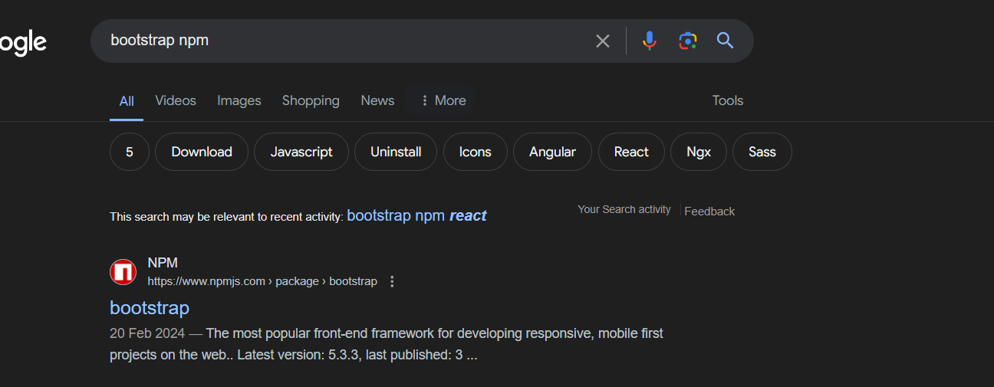

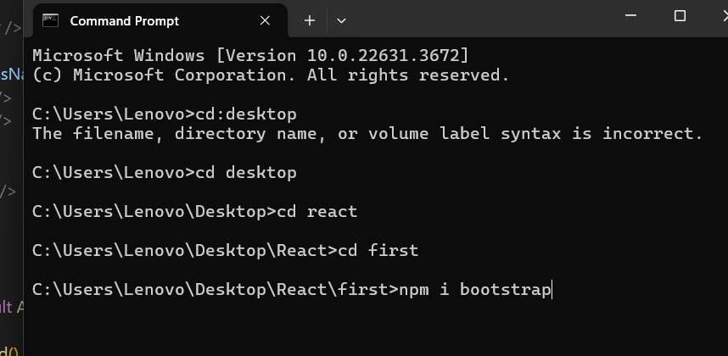

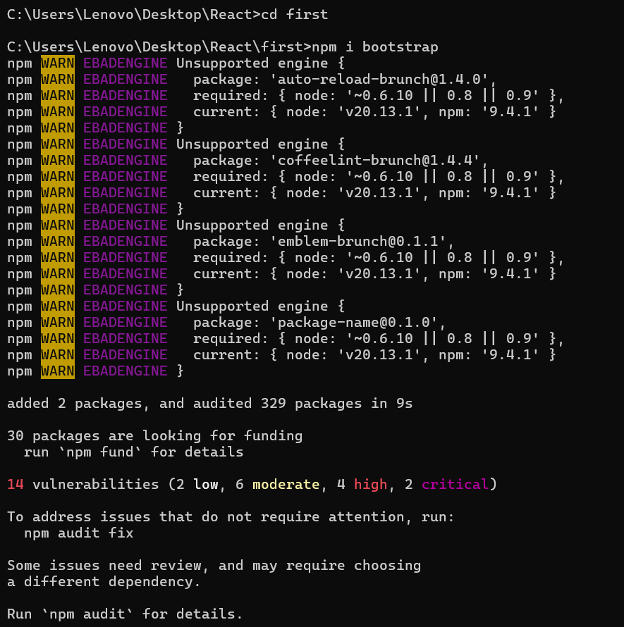

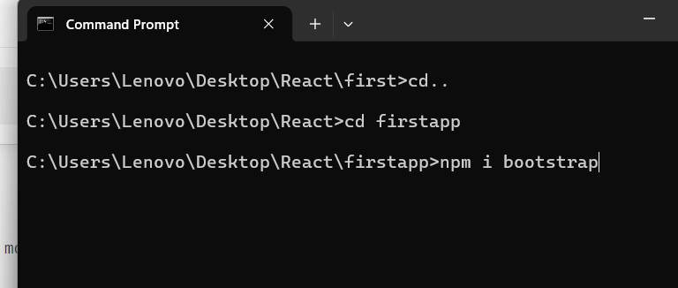

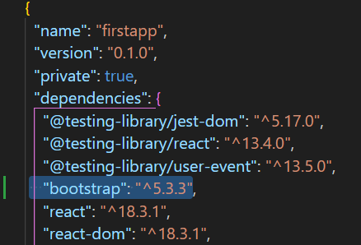

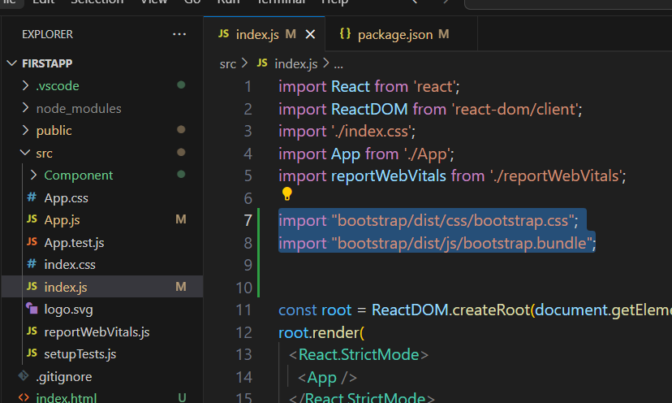

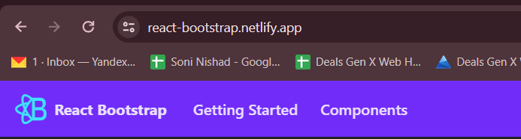

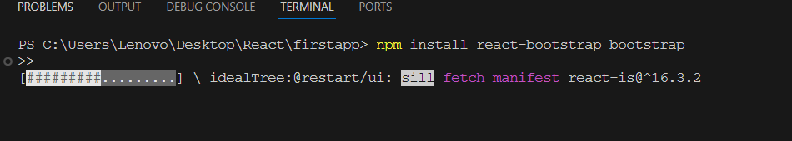

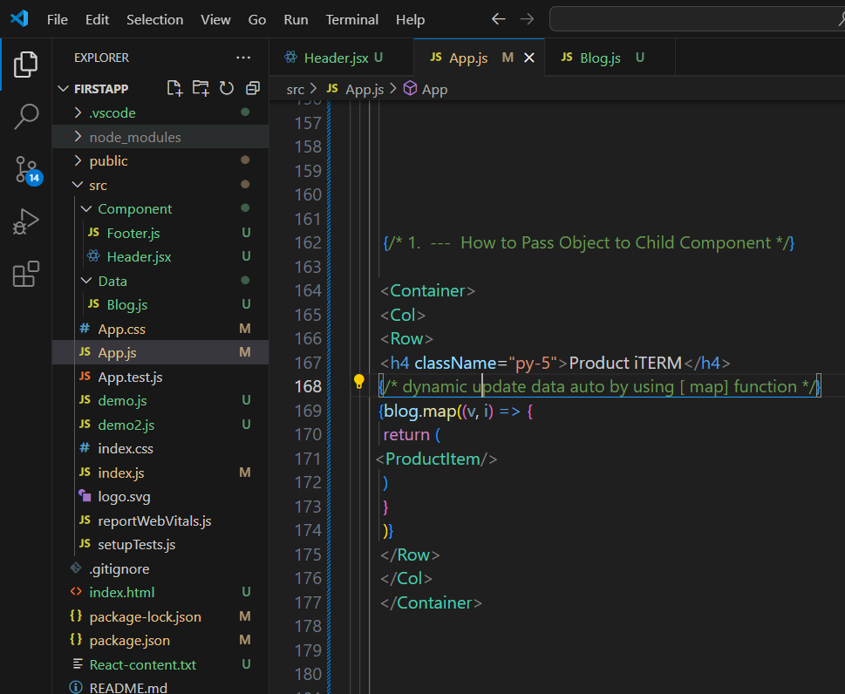

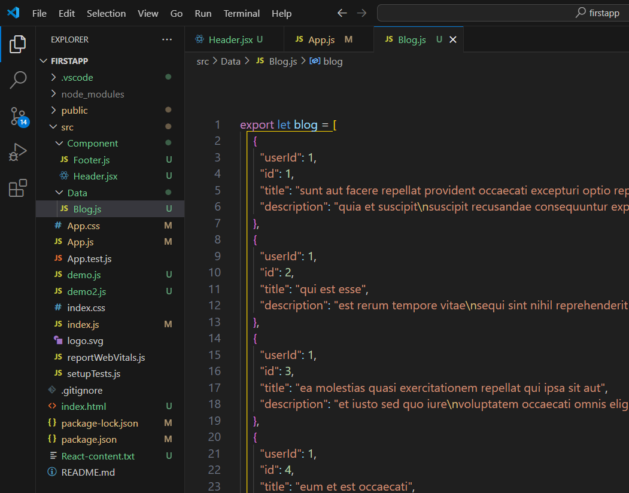

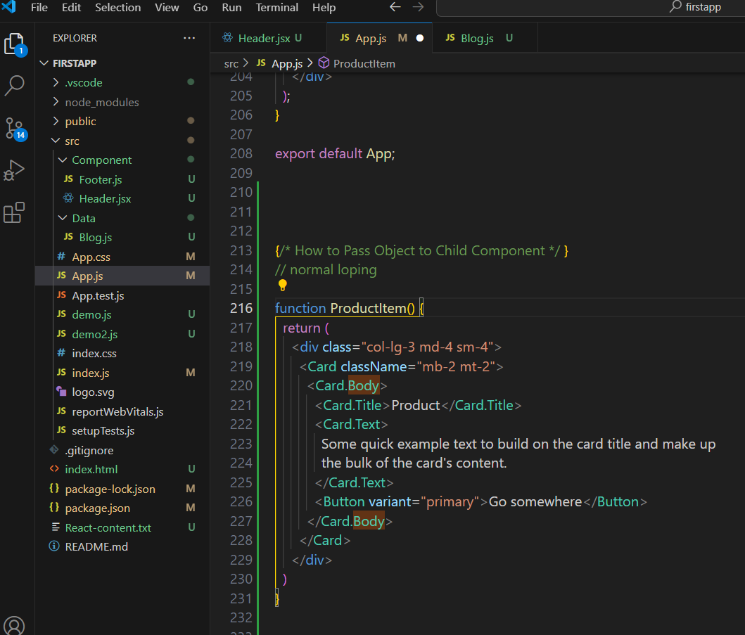

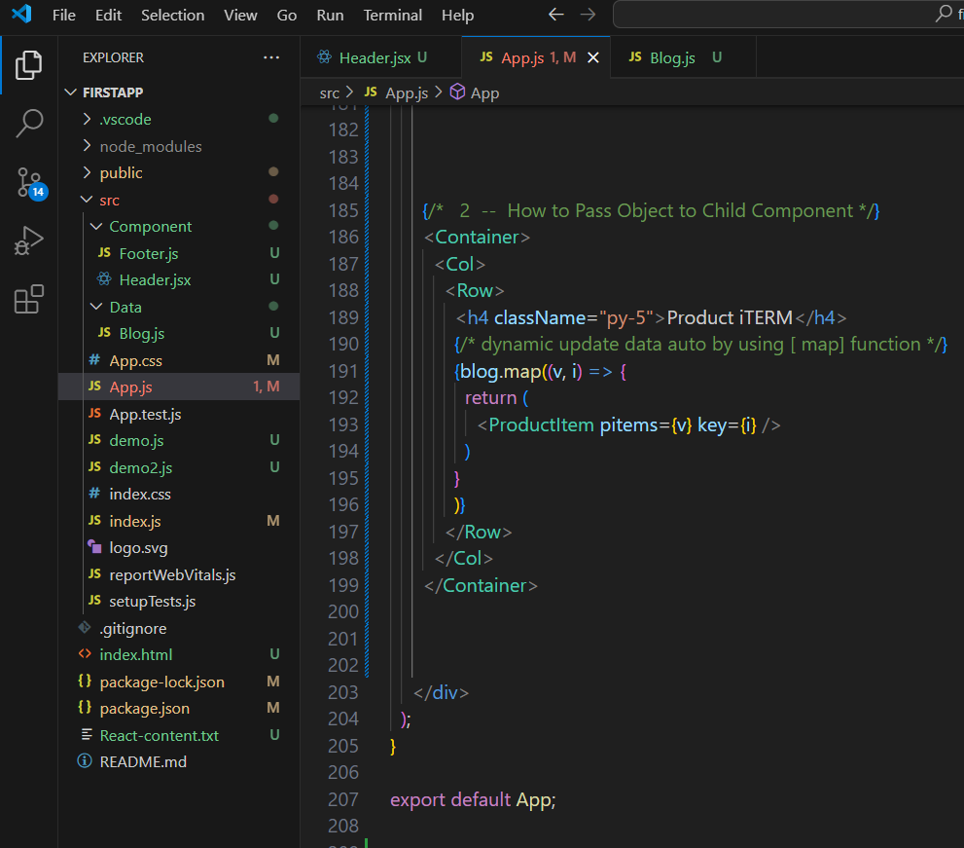

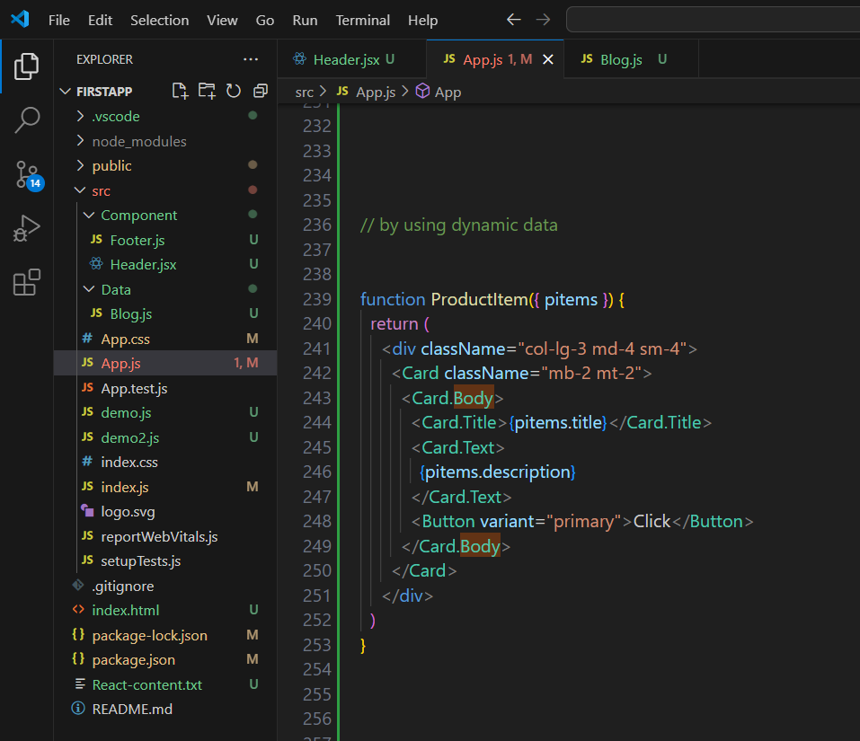

How to add Font-Awosme –

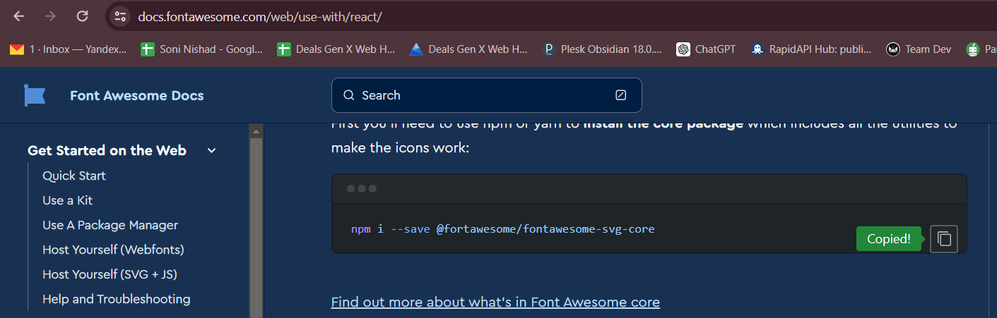

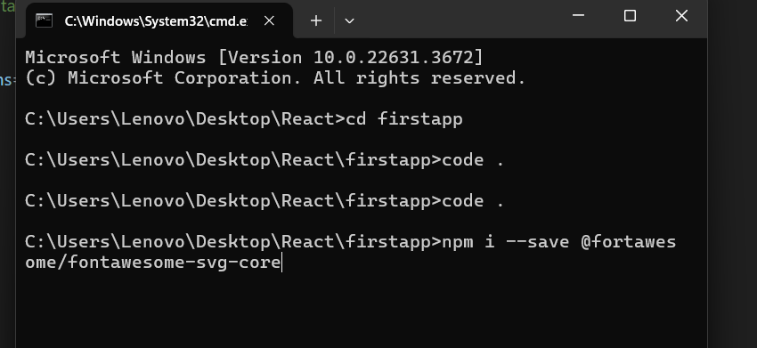

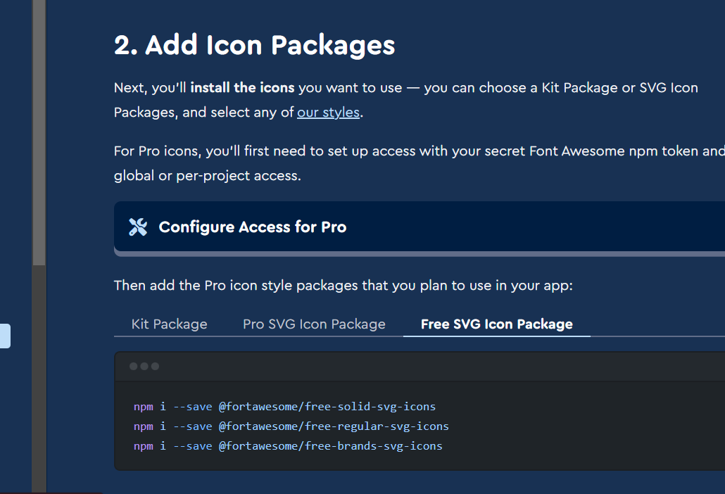

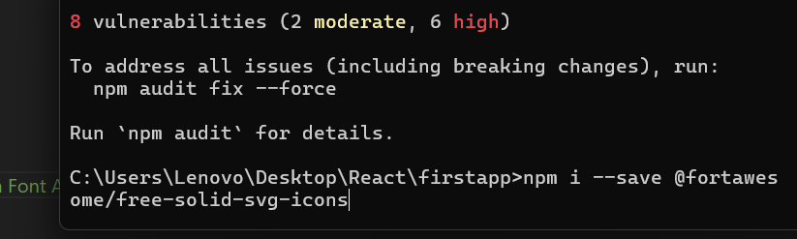

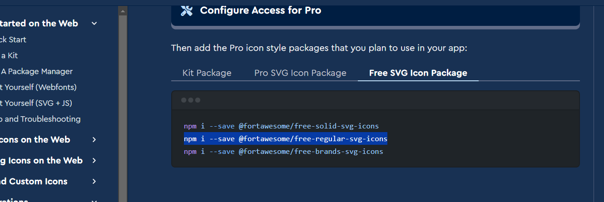

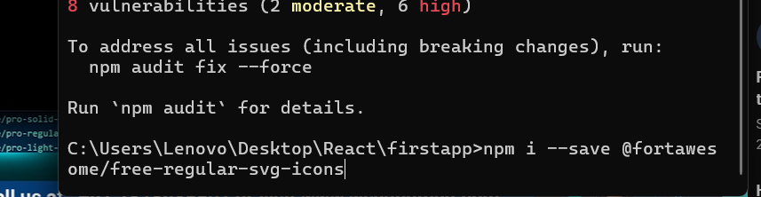

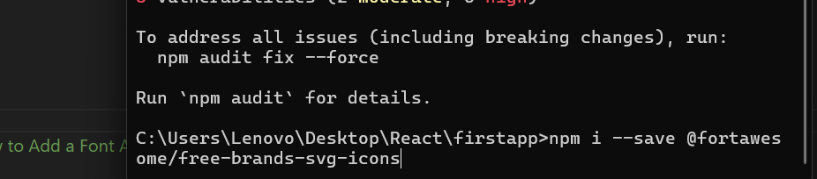

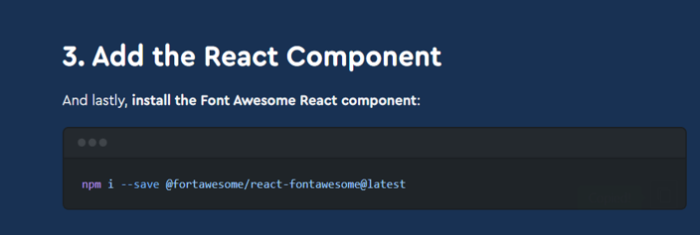

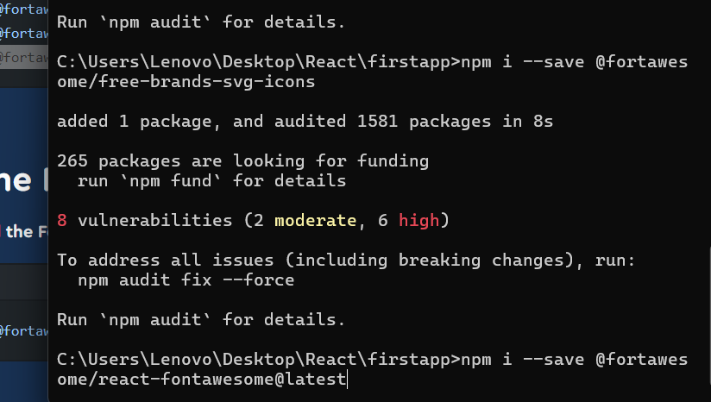

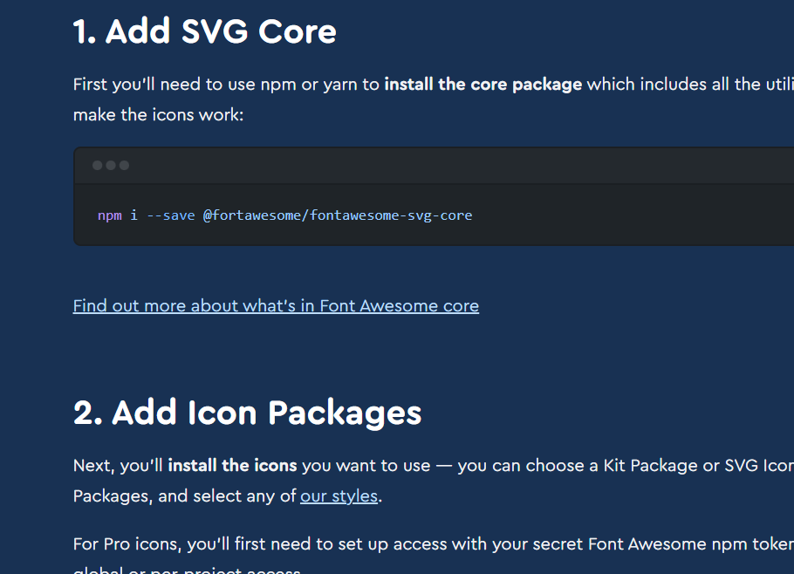

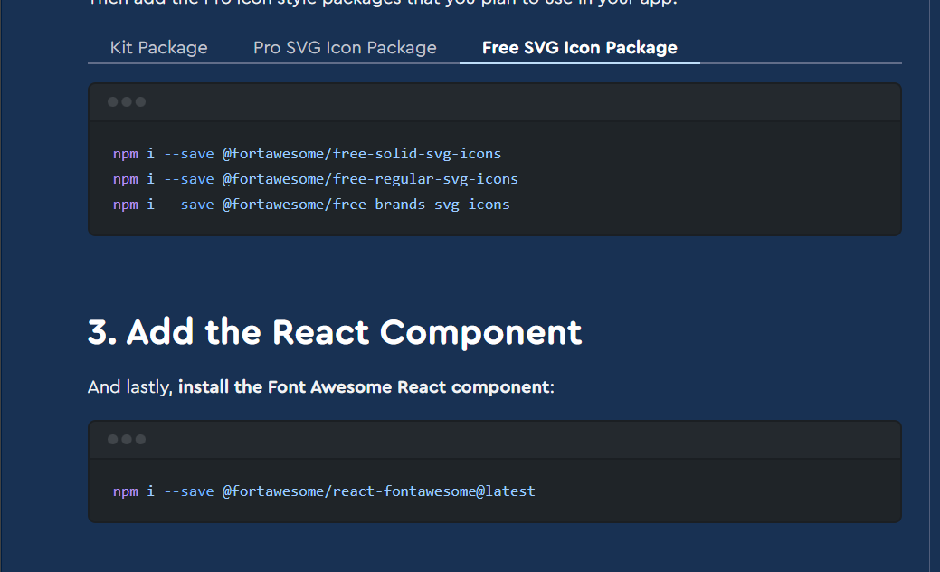

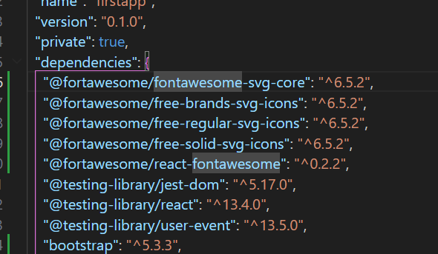

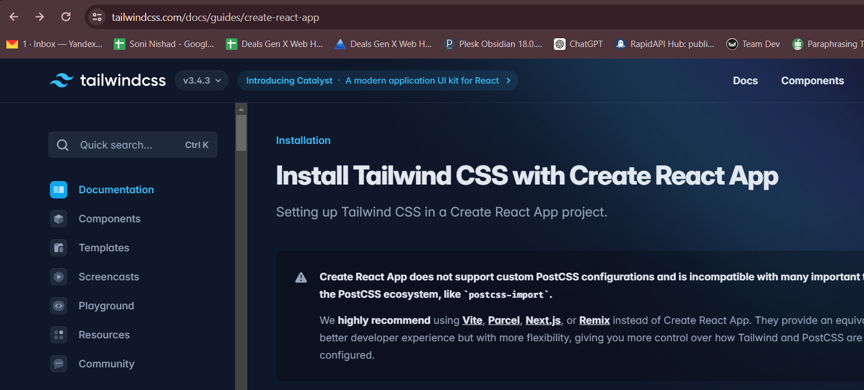

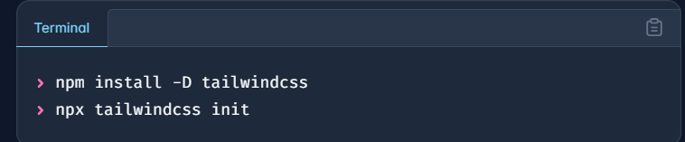

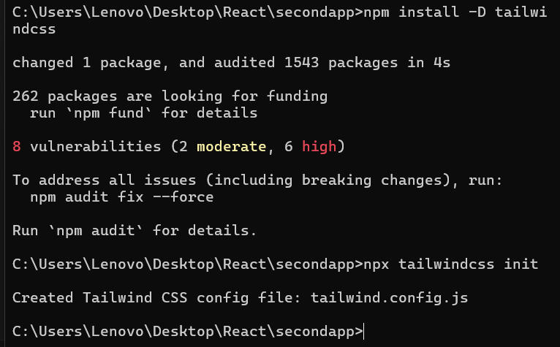

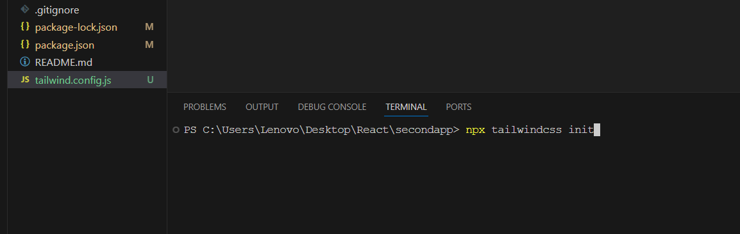

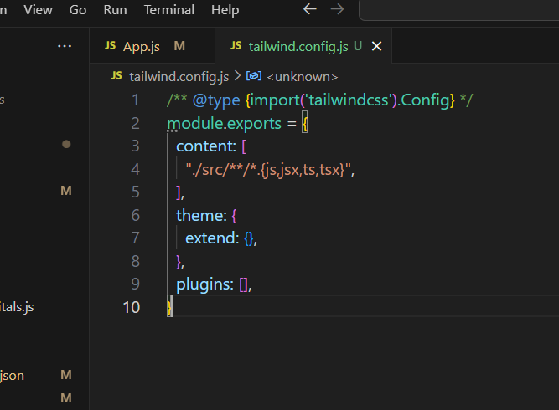

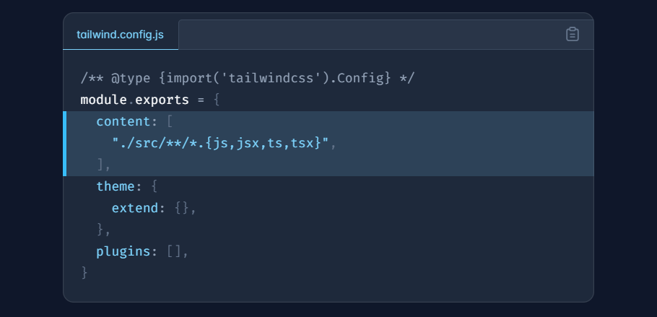

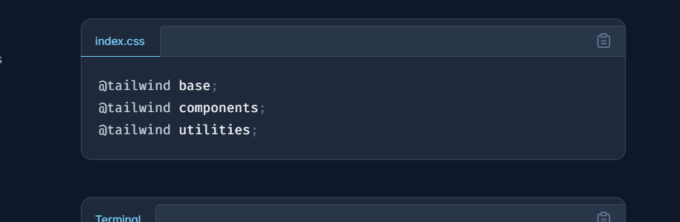

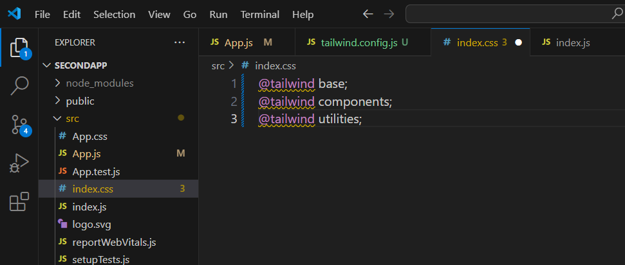

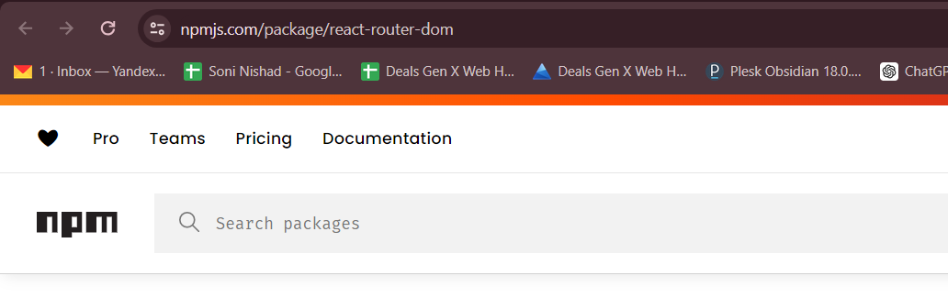

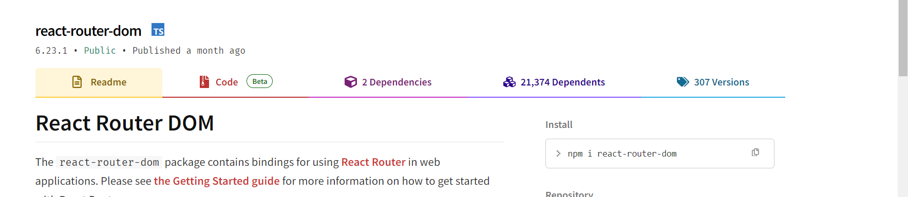

* For routing install
* **npm install react-router-dom**

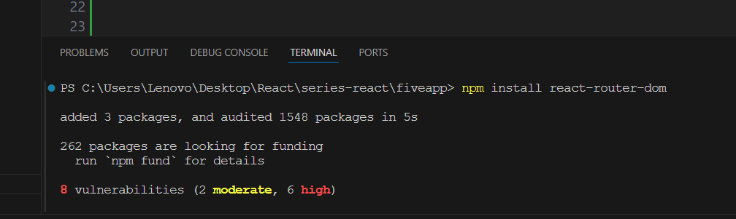

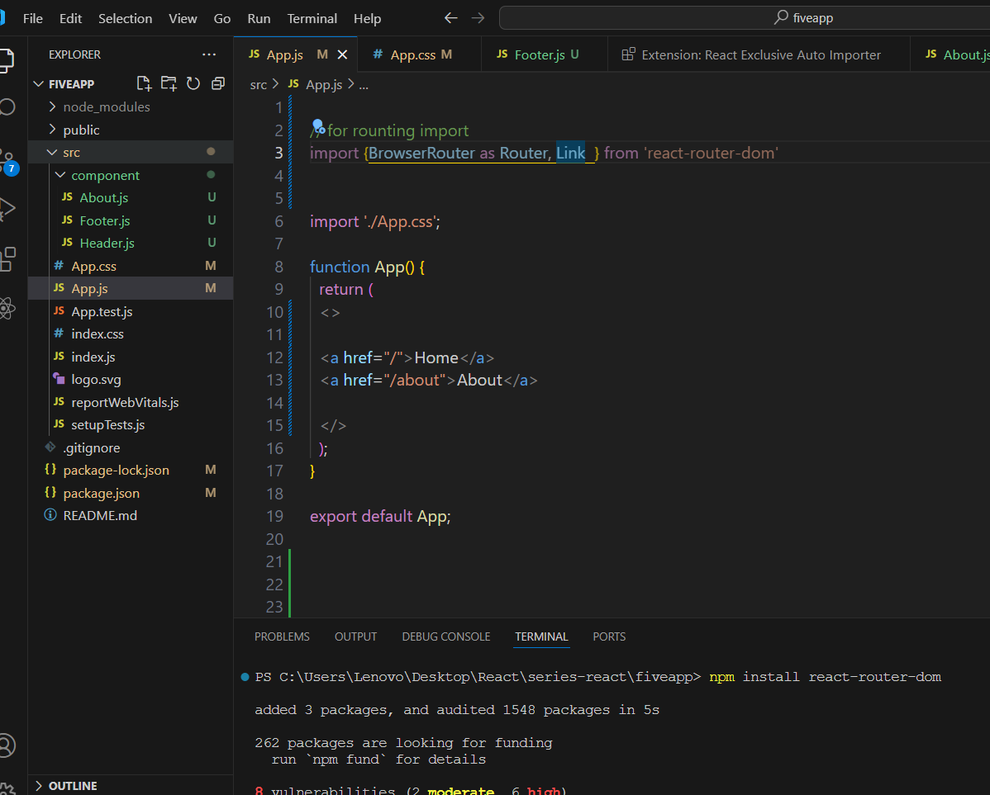

React Vite project live run 🡪 by downloads

1. npm install
2. npm run dev
3. run successfully

